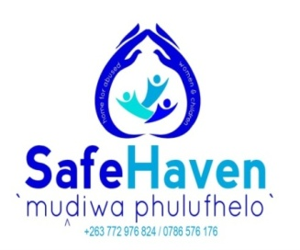

Organizational Profile

  - Name of Organization: Muḓi wa Pfuḽufheḽo Safe Haven

  - Organization status: Non-Profit Organization

  - Registration Status: Registered as a Trust

  - Registration Number: Protocol No.106/2019

  - Date of Registration: 02 September 2019

  - Address: 3913 Mangavha shopping
  - Centre, Beitbridge
  - Region: Matabeleland South

  - Website: www.mudisafe.org.zw
  - Social media: (Facebook) Safe Haven Beitbridge
  - Contacts: 0772976824/ 0772405924

- Background

Muḓi wa Pfuḽufheḽo started as a pipeline dream for a Beitbridge based Social Worker; Babongile Gora who then sold the dream to her husband, Claude Gora and together they founded the Organization. The dream started in 2011 and it came after she discovered that there was a gap in Service provision for Sexual and Gender Based Violence Survivors. Sexual and Gender Based Violence refers to Violence that targets individuals on the basis of their gender. Although over the years, violence perpetrated against men has become rife; Women and children are the main victims, hence them being the target population for MWP Safe Haven. SGBV can be Sexual, Physical, emotional and Economic. Beitbridge District has a high number of Sexual and Gender Based Violence (SGBV) cases that are being reported on a daily basis. Although there are many Service providers in the District who deal with such cases; the available Centers attend to walk in Clients only. This means that the Survivors of SGBV only receive partial care. After getting treatment, they are sent back to the same environment where they were abused and this hinders their recovery. MWP provides a holistic package that ensures that the Clients are provided with Safe care while they get services. The most reported cases are Rape by known Perpetrators (especially those of Children), Statutory Rape and Domestic Violence.

Muḓi wa Pfuḽufheḽo means Home of Hope and our main purpose is to bring hope to Survivors of all forms of Sexual and Gender Based Violence. It’s a temporary shelter that caters for survivors for a maximum period of 6 months; within which they will get Psycho-Social Support and training in Income Generating Projects. The aim is to make the Survivors independent so that they can be able to make it on their own after their release
We help our Clients to heal after having survived abuse by providing Trauma Counseling as well as ongoing Psycho-Social Care. We offer proven expertise in counseling services as one of the Directors is a qualified Social worker who was also trained in Therapy. Our solutions include training the Clients in Life skills as well as Income generating Projects so that after their stay at the shelter; they will be independent financially.

- Objectives
  - Provide temporary Shelter to at least 500 survivors of Sexual and Gender Based Violence by 2025
  - To provide Psycho-Social support to the same.
  - To promote Gender equality and empower clients
  - To promote clients’ rights and prevent SGBV

- Vision
“Empowered, Resilient Women and girls who choose to be Survivors against all odds”

- Mission
Muḓi wa Pfuḽufheḽo Safe Haven is a Home that is committed to providing safe care to Survivors of Sexual and Gender Based Violence, ensuring that they get Psycho-Social Support, Gender equality and Empowerment.

- Core values
  - Service to others
  - Women Empowerment
  - Integrity
  - Protection
  - Compassion
  - Responsiveness

- Target group
Women, Girls and boys of all ages. Men are provided with a partial service; they receive Psycho-
Social Support then get referred to relevant Service Providers.

- Activities
- A file is opened for each and every individual upon admission to the Shelter.
- Interviews are then conducted and Intake forms that highlight the Beneficiaries’ circumstances are completed for filing.
- The survivor is linked with relevant Service providers like the Hospital for Medical care treatment and Affidavits as well as the Police and the Courts.
- Psycho-Social Support is commenced; within which, a care plan is drafted. During their stay at the Safe Haven, Survivors partake in daily activities like dress-making, mat-making, gardening and jewelry making.
- Life skills are taught at the Centre. When the Survivors are deemed fit by the resident Social worker, an Exit plan is worked on with the Survivor.

- Other Activities
- The Organization holds Youth Camps as well as Ladies’ retreats for the Purpose of teaching women and the Youth about Sexual and Gender Based Violence as a preventative measure.
- Community Dialogues are held on SGBV Issues
- Sensitization meetings are held in Clinics, Churches as well as Social gatherings

- Project Pictures
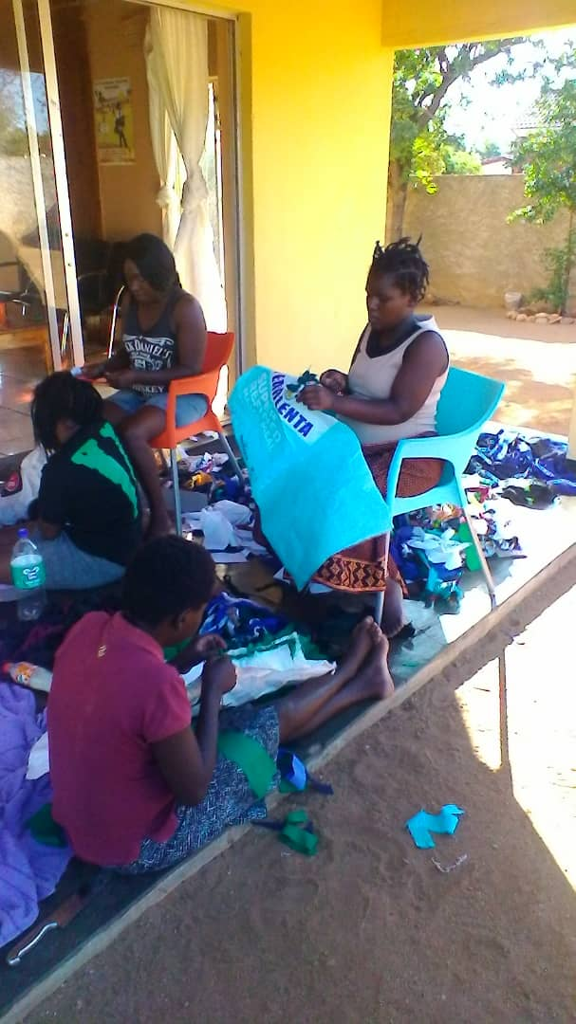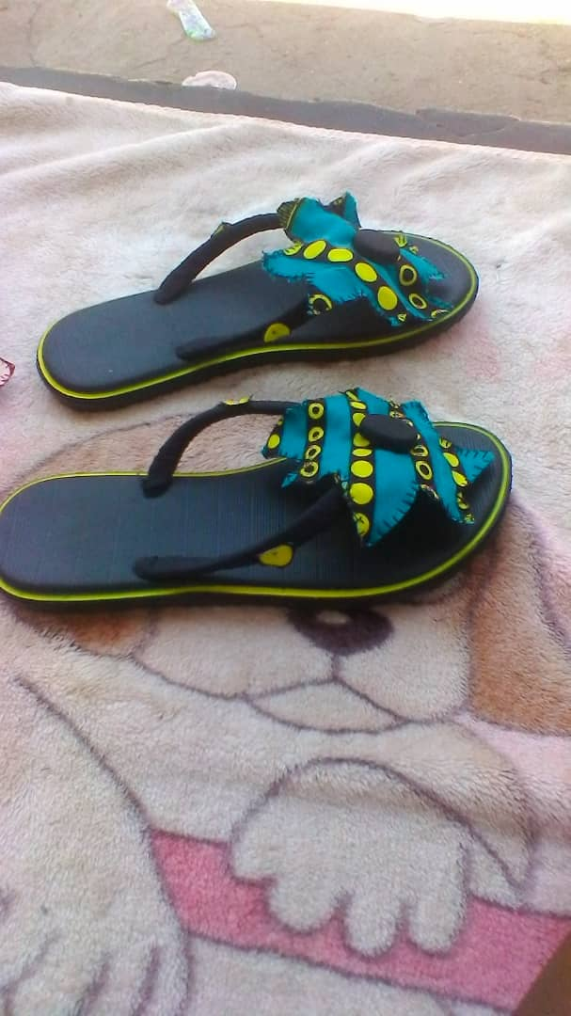
The Beneficiaries making mats Slopes that are decorated by the beneficiaries for re-sale
Beneficiaries make mats, vases and earrings from scratch and also buy stuff like slopes, modify them and re-sell them as part of their projects.
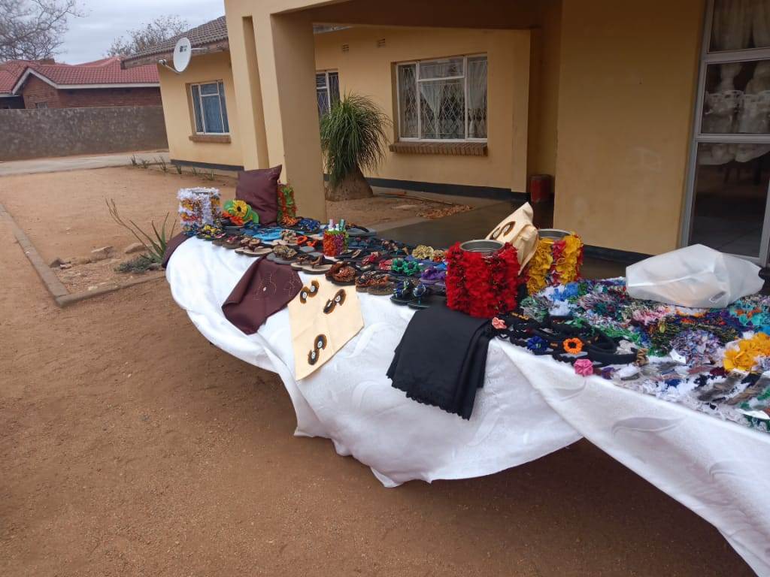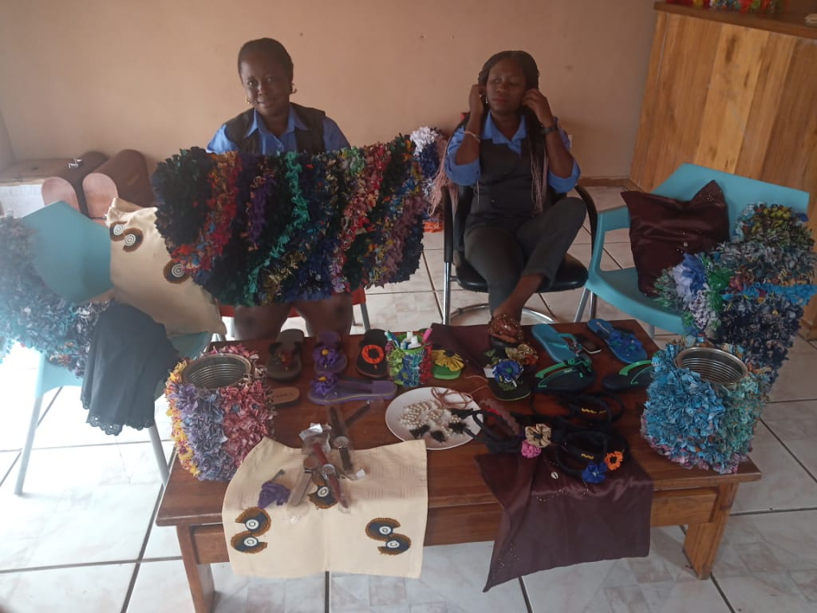

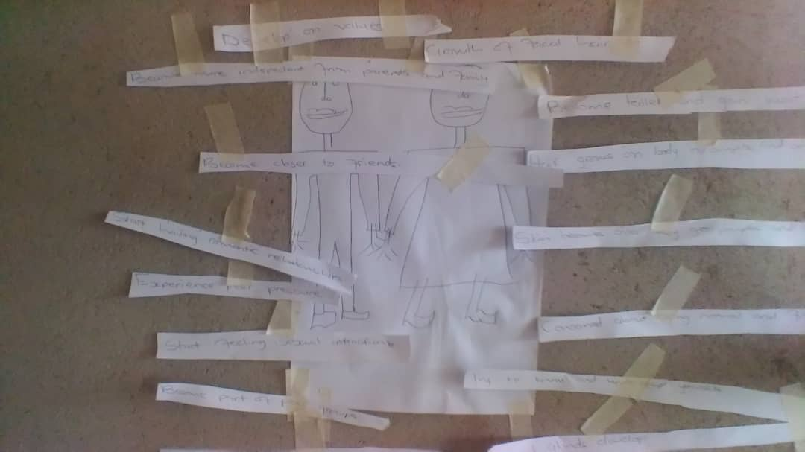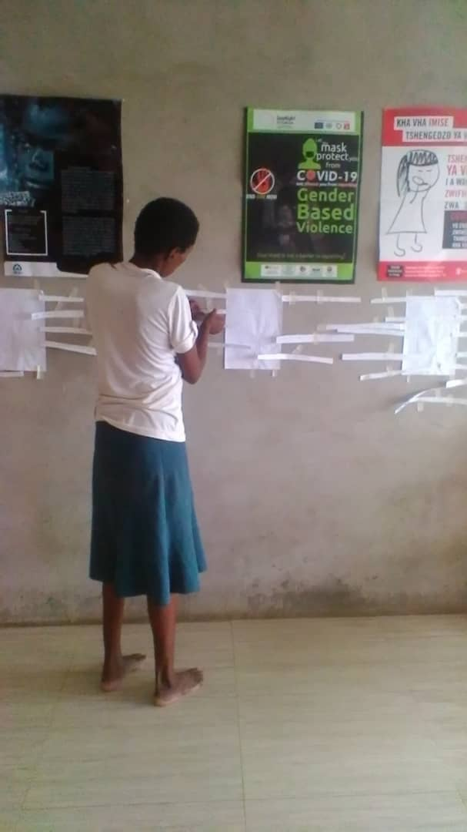
Life skills training
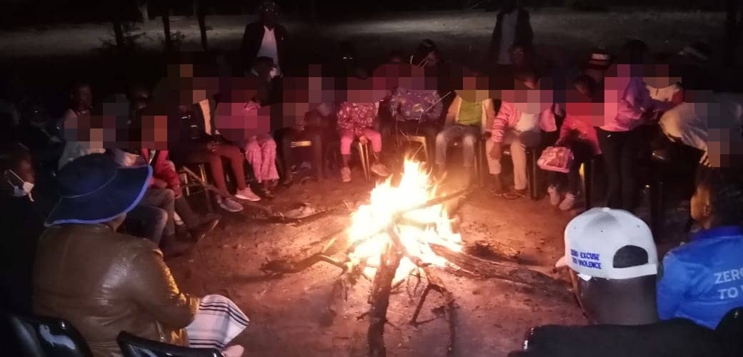
Youth Camp

