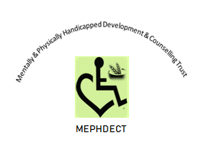
Title | MEPHDECT ORGANISATIONAL PROFILE
Submitted To | Kubatana
Submitting Organisation | Mentally and Physically Handicapped Development and Counselling Trust (MEPHDECT)
Contact Person | Ephraim Matinhira
Contact Details | 286 Northway Road, Prospect/Waterfalls, Harare. Phone: 263 (242) 589242. Cell: 263 772 582 651.  Email: disabilityandcounselling@gmail.com
Region of work | Mashonaland East Province : Goromonzi district
Facebook page | MEPHDECT
Date Submitted | March 2022

- ORGANISATIONAL DESCRIPTION and LEGAL STATUS:
Mentally and Physically Handicapped Development and Counselling Trust (MEPHDECT) is a Zimbabwean registered (542/2019) non-profit making institution dedicated to improve marginalized rural communities’ livelihoods through sustainable and community driven psychosocial development approaches. The organization promotes sustainable and climate adaptable farming practices and ecological farming for improved food, nutrition and income security. MEPHDECT aims to promote water availability, sanitation and hygiene services provision. The organisation is geared to facilitate creation of gender sensitive community owned productive jobs along the value chain and entrepreneur skills training as a strategy to promote gender equality in socio-economic development processes and to reduce poverty. Finally, the organization programs aim to increase the number of underprivileged children including those living with disability access descent education and vocation training for skills development.

- PROGRAMME FOCUS AREAS:
MEPHDECT development activities are articulated under 4 thematic programme areas of focus listed below:
- Education and Psychosocial Support based on the increasing number of silent victims especially orphans and vulnerable children (OVC) including those living with disability and the prevalence of emergencies (droughts, floods pandemics and inflation).
- Water, Sanitation and Climate Adaptation were identified on the observation of climate change and declining water and sanitation services provision.
- Food and Nutrition Security and Livelihoods were identified based on worsening hunger and poverty in marginalised communities.
- Economic Empowerment and Gender Equity thematic areas were identified as a response to increasing lack of formal employment opportunities, gender inequalities, increasing female and child headed households in the rural communities.
2 (a) Human Rights Cross Cutting Activities:
MEPHDECT makes deliberate efforts to incorporate human rights issues through workshops and policy awareness campaigns and advocacy in all its programme formulations. The specific cross cutting activity areas include:
- Children’s rights:
The law protects children from being subjected to any form of physical or psychological torture. There are gaps which hinder equal opportunities and access to decent education of marginalized girl pupils including children living with disabilities in schools. The girl child and children living with disabilities lack adequate resources in terms of school and humanitarian provisions and career guidance development to allow them to realise their full potential. This challenge compels the adolescent girls to shy away from school and consequently forcing them to opt for school absenteeism or dropping out of school completely, which then promotes child marriages. Children living with disabilities have no adequate assistive tools such as hearing, seeing, walking aids. In some schools the environment is not inclusive making it difficult for children with disabilities to access places as they desire. In a majority of cases, children living with disabilities do not complete their academic obligations because of the identified challenges. The identified challenges above recognise that education is a pillar to break the cycle of poverty in the long run. Furthermore, education will empower the least privileged in society to move out of welfare recipients to active participants in community development initiatives.
- The right to descent life:
Recurring challenges such as droughts, floods and pandemics negatively impact on the decency of community livelihoods. These phenomenon expose communities to physical and psychological suffering and hence the need to provide developmental psychosocial interventions including social nets to build community resilience and descent livelihoods.
- The right to food:
The marginalised communities are not adequately educated on the right to adequate nutritious food for all, at all times. A majority of children are exposed to abuse including girl child marriages as the only possible solution to access food with the hope of moving out of poverty. The communities and traditional leaders need to change their mind set and recognise women’s pivotal role as champions of household food, nutrition and dietary diversity and the cultural mentors of the girl child.
- Economic rights:
There is a lack of employment opportunities and income generating activities in the rural areas, particularly for women who spend most of their time at home, yet there is vast potential to create gender sensitive household owned productive jobs along the value chain. In Zimbabwe women contribute 80% of agricultural labour despite the fact that they don’t own assets of production and in most cases they are considered as sources of cheap labour. They predominantly work as unpaid labour at household level with limited powers in the final decision making process. Women are highly industrious yet they have limited opportunities for vocational training in entrepreneurial income generating projects and small business management skills.
- Access to clean water, sanitation and hygiene
Clean water, sanitation and hygiene (WASH) services provision are deteriorating particularly in the marginalised communities who are already exposed because of lack of capacity to mobilise resources. The environment surrounding the marginalised communities are a potential health hazard and further exposes people to nutrition and dietary diversity insecurity. There is limited effort to organise health awareness campaigns and resource mobilisation to alleviate the deteriorating WASH crisis.
- Gender equality:
Women have limited participation in community programs, leadership roles and involvement in influential community decision making processes. This perpetuates their poverty and widens the gap in equity and equality between the two genders. On the other hand, the girl child has less preference to education and career guidance opportunities as compared to the boy child. This scenario exposes the girl child to challenges which perpetuates the cycle of poverty.
- Governance:
The traditional and cultural structures limit women’s active involvement in deciding the norms, rules and actions that determine their socio-economic empowerment to enable them to realise their full potential in life and reduce the gender gap. Women are not part of the traditional leadership structures and are poorly represented in the economic, social and cultural spheres.
- PROGRAMME BENEFICIARIES
MEPHDECT programmes are designed to benefit the whole project sites communities and beyond either directly during implementation phase or indirectly as a spill over effect of the project impact. The direct programme beneficiaries for the four thematic areas and cross cutting activities are listed in the table below.
Programme | Targeted Beneficiaries
Education and Psychosocial Support | *Underserved children (orphans, vulnerable, disability and the girl child)  *Households living with people with disabilities  *Female headed households  *Child headed households  *Victims of emergencies (droughts, floods, pandemics, gender based violence)  *Traditional leaders and policy makers
Water, Sanitation, Hygiene (WASH) and Climate Adaptation | *Marginalised rural communities with collapsed WASH infrastructure  *Marginalised rural communities with critical need for WASH services provision  *Households living with people with disabilities and the elderly  *Schools, Health centres, rural service centres  *Communities in need of nutrition gardens.  *Traditional leaders and policy makers
Food and Nutrition Security and Livelihoods | *Marginalised rural communities in low rainfall areas especially natural regions 4 and 5.  *Marginalised female headed households  *Marginalised child headed households  *Households living with people with disabilities and chronic ailments.  *Stakeholders working in project areas  *Traditional leaders and policy makers
Economic Empowerment and Gender Equity | *Women and girls in the productive age group  *Local traditional leaders and policy makers  *Youths  *Very poor households  *Vocational training centres

- INSTITUTIONAL CAPACITY STATEMENT:
The action oriented MEPHDECT has earned strong recognition with both administrative structures, communities and stakeholders in the current province of influence (Mashonaland East Province) and among likeminded development organisations. The organisation has registered many successes in both Institutional Capacity Building processes and Programmes Development and Implementation skills.

4 (a) Programme achievements were in the following thematic areas:
Education/Psychosocial Support:
In the 2019 to 2021 academic years MEPHDECT managed to mobilise resources from members of staff from likeminded institutions and the private sector who have a heart for vulnerable children including orphans and those living with disability to enable them access primary education and psychosocial support. The underserved children were identified on a gender sensitive criteria (60% girls: 40% boys) at Mapheni and Mwanza Primary Schools in Goromonzi district of Mashonaland East Province. The organisation managed to make direct educational and humanitarian assistance provisions which included school fees payments, stationery, sanitary wear and health awareness campaigns. However, this programme faced challenges of unexpected sudden closure of schools and the subsequent lockdowns due to the outbreak of the covid-19 global pandemic.
Water, Sanitation and Climate Adaptation:
In 2020 MEPHDECT engaged with Australian Aid -: Development Assistance Programme (DAP) at the Australian Embassy in Harare to implement livelihoods improvement support projects in Goromonzi district of Mashonaland East Province. The organisation successfully implemented the community project consultative and identification process. The key outcome of the consultations was the development of a 3 in 1 development strategy for the Water, Sanitation and Hygiene (WASH) Support Project where water would be supplied to a school; rural service clinic and to irrigate a community nutrition garden. The project was intricately linked with Food and Nutrition Security programme to enhance community dietary diversity and support the school feeding program. The notes and outcomes of the community WASH consultative process were shared with the Australian Embassy for information.
The major challenges were the covid-19 pandemic and limited funding which negatively impacted on implementation of identified project activities.

Below are some of the snapshots captured during the community consultative process in Goromonzi district.
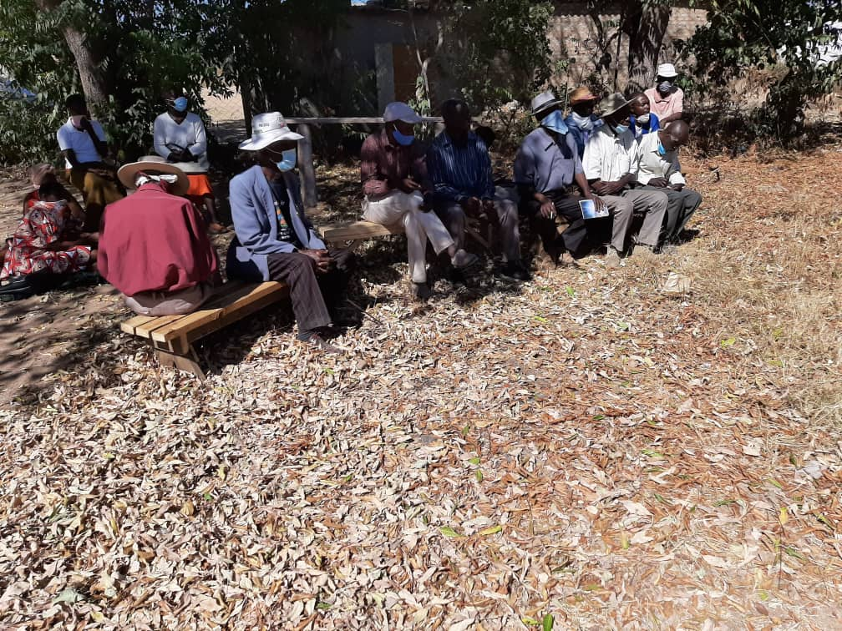
Figure 1 Chief Mwanza with a hearing challenge attending a community consultative meeting with a fellow villager facing opposite direction to whisper deliberations to his ear

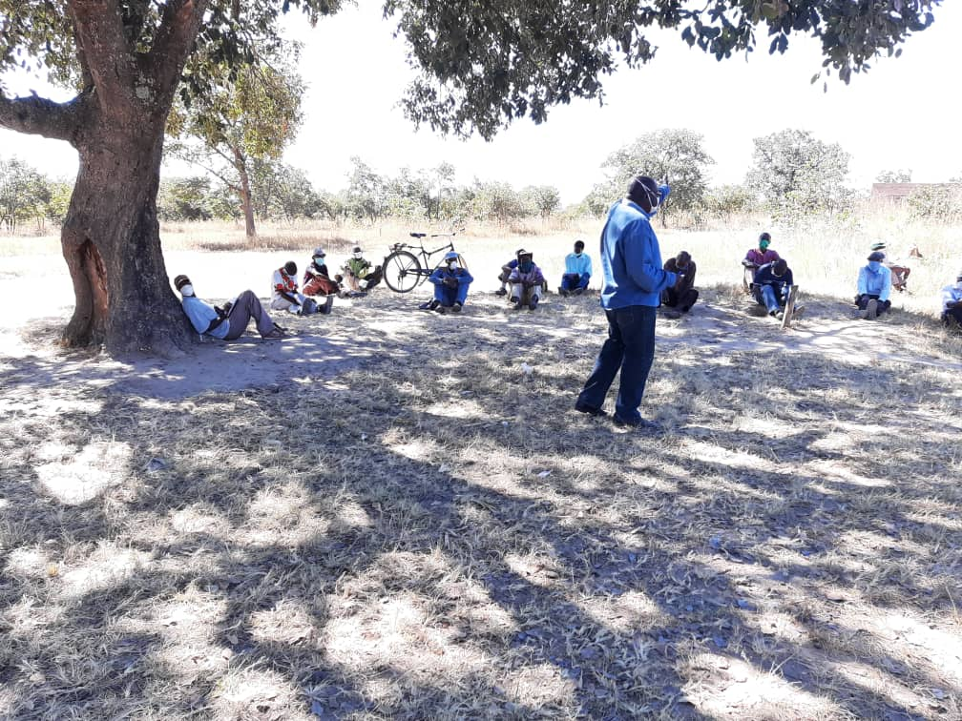
Figure 2 The ward councillor Mr J. Kachanga emphasising a point during the consultative meeting
The consultations further successfully established that a role model centre with appropriate facilities for sanitation and hygiene where medical personnel would take opportunity to train villagers on sanitation and hygiene especially in the wake of the covid-19 pandemic among other diseases should be constructed. Furthermore, the process considered establishing greenhouse nutrition gardens. This would bring a unique opportunity that would show case effective, modern and climate-smart methods of crop production for improved yields and production of high quality produce for food, nutrition and income security. The greenhouses would be demonstration centres/learning-hub for Farmer Field Schools’ (FFS) trainings.
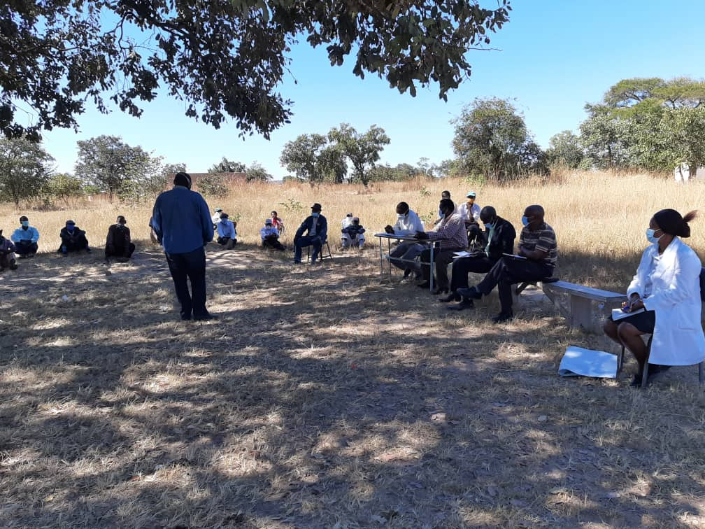
Figure 3 The Sister in Charge at Rusike Rural clinic in white dust coat awaiting to give a covid-19 awareness talk during the community consultative meeting
During the consultations MEPHDECT managed to adopt and implement the covid-19 prevention measures precisely social distancing; limited number of participants to below the stipulated (50) per gathering, use of masks and sanitizers as demonstration to the communities of the organisation’s commitment to good health practices.
Finally, in all its interventions, MEPHDECT has adopted a position to be covid-19 responsive, respect local culture and by-laws to establish long term relationships with communities and implement sustainable interventions.

