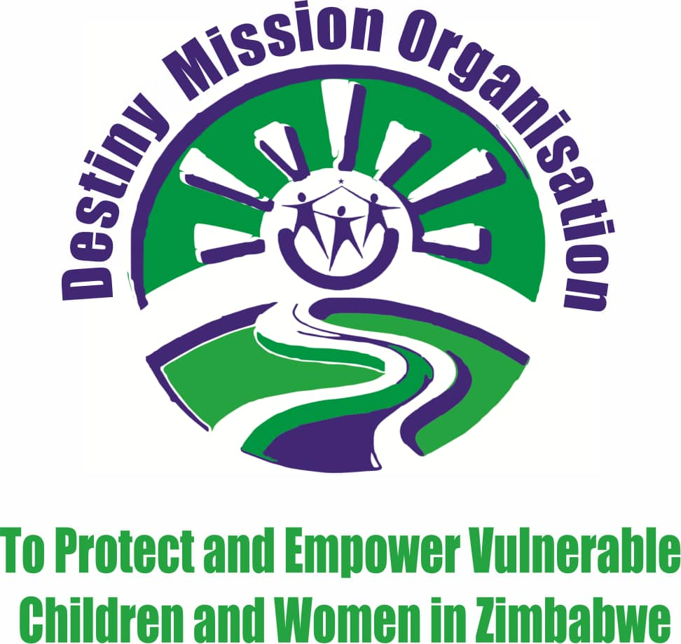

ORGANISATION INFORMATION SHEET
Name: Destiny Mission Organisation
Registration status: PVO
Type of organization: Community Based Organization
Areas of operations: Eastern District of Harare and Goromonzi Distict

Address: 146 Kwame Nkruma
Westminster Court
Suit 17
Harare

Phone number: +26308644282195/+263774641416 call/whats app

Email: info@dmo.org.zw
admin@dmo.org.zw
hr@dmo.org.zw

Website:www.dmo.org.zw
https//www.facebook.com/destinymissionfoundationtrust htt://Instagram.com/destinymissionorganisation?utm- medium=copy-link
www.youtube.com/channel/desmis

Country: Zimbabwe
Background
Destiny Mission Organisationis a community-based organization which was established in 2010 and legally registered as a Trust in 2014 in the name Destiny mission foundation Trust with a registration number 0000392/2014. It ran as a Trust as from 03 April 2014 to10 March 2021. On 10 May 2021 registered as a PVO with a PVO registration number PVO94/20in the name Destiny Mission Organisation(DeMO) We are operating in the High-density suburbs of Harare Metropolitan Province. We intend to spread operations to other areas including rural areas subject to identification of need and consent of the local Authority. It was formed by a group of academics who are experienced in social development and social education with a vision of empowering women and vulnerable children in Zimbabwe. Destiny MissionOrganisation was formed due to the challenges confronting children and women in high density and rural areas of Zimbabwe. School dropouts, child sexual exploitation, poverty, gender-based violence, unemployment, HIV and AIDS, child abuse and economic hardships are the major miseries warranted the formation of Destiny Mission Organisation. Children should be protected from any activities that could harm their development.
A lot of children are dropping out of school due to closure of industries, poverty and orphan hood. The children especially boys engaged in criminal activities, alcohol and drug abuse. Girls are being abused and exploited and some indulge in transactional sex to meet basic and other needs. Children are exposed to hostile environment characterized by sexual transmitted diseases, early pregnancies and early marriages.
The organization is based in Harare and it operates in the Eastern District of Harare Metropolitan Province: Mabvuku, Tafara, Eastview (Caledonia).
Destiny Mission Organisation empowers children and women through livelihoods skills training andprojects,by doing so we are promoting mental health among children and women in Zimbabwe
Mission
Promoting mental health through empowering and protecting vulnerable children and women in Zimbabwe.
Vision
“A transformed society that cares for and support mental health of vulnerable children and women in Zimbabwe”.

Goal
To be a distinguished organization that facilitates sustainable development programs through improvingchildren and women’s mental health by providing them livelihoods projects.
OBJECTIVES
1.To raise community awareness on children`s rights.
2. To provide educational assistance to the vulnerable children.
3. To provide resdential care facilities to vulnerable children.
4. To provide psychosocial support to vulnerable children through sports activities.
5. To promote livelihood projects to guardians of vulnerable children.
6. To promote gender equality and equity.
Values
- Children and womencenterdness
- Equity and equality
- Non-discrimination
- Honest
- Respect
- Transparency
- Accountability

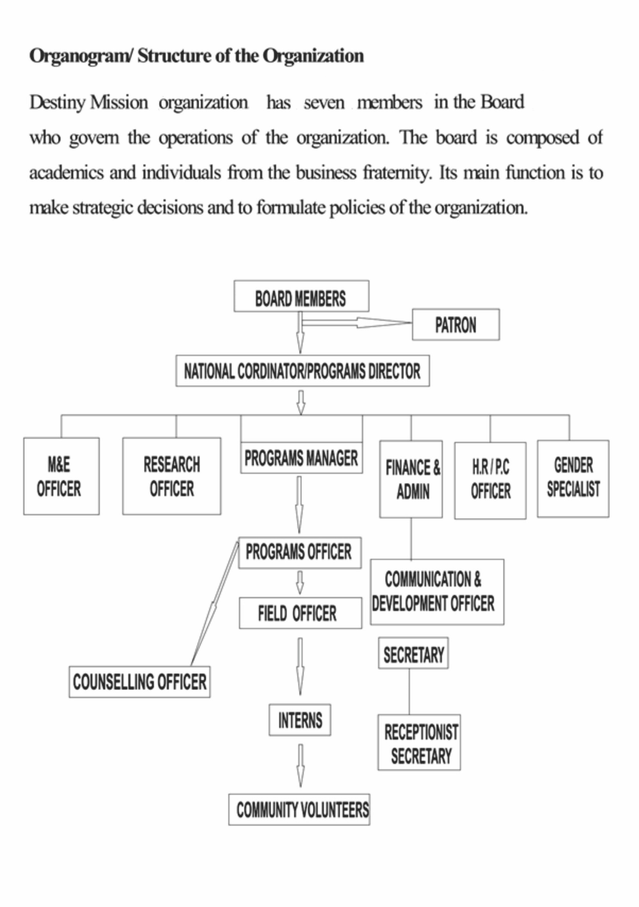

Programs
1 CHILD CARE AND PROTECTION
- Destiny Mission Organisation aims to meet the basic needs of children and also to protect children from any form of harm.
- Basically child care can be understood as the provision basic services meant for the wellbeing of children.
- These basic needs include food and nutrition especially for children, shelter, sanitation and clothes.
- It is also the aim of Destiny Mission Organization to protect children from any form of harm, thus, sexual abuse, physical abuse and child marriage.

2 WOMEN AND CHILDREN`S RIGHTS
- It is a mandate of the organization to create an oasis of security, happiness and development of all children and women
- Children’s rights is a broad program that covers wide horizons that embraces birth registration, child protection committees (CPC) as well as child participation and safeguarding the children’s interests.
- Thus Destiny Mission Organization ensures such through visiting different homesteads around its areas of operation identifying families with children who have no birth certificates.

3 GENDER BASED VIOLENCE AWARENESS
- Destiny mission Organisation aims to protect women from any form of Gender Based Violence (GBV).
- GBV is defined any form of harm against an individual based on gender.

- GBV can be in form of physical, emotional, psychological, economical and sexual abuse
- As an organization we educate people and raise awareness about GBV, offer counselling to the victims and also livelihood projects to the survivors
- If the case is beyond our capabilities we refer the clients to other relevant stackholders.

4 EDUCATIONAL ASSISTANCE
- Destiny Mission Organization aims to ensure children from disadvantaged backgrounds ( orphaned children, child headed families, children in situations of abuse, children living with disabilities and children of single parented adolescents and young mothers)are afforded a chance to quality education.
- The ultimate outcome is for children to attend school from primary through secondary level and complete their educational cycles.
5 PSYCHO-SOCIAL SUPPORT
- Destiny Mission Organization aims at ensuring the provision of care and support to the vulnerable children and women in Zimbabwe by offering psychosocial support through sports.
- This assist in identifying different challenges faced by certain target groups and it helps in how best one can offer solutions to certain problems.
6 LIVELIHOOD PROJECTS TO THE GUARDIANS OF THE VULNERABLE CHILDREN
- In order to achieve what you aspire for as an organization, Destiny Mission Organization performs livelihood projects to guardians and caregivers of the vulnerable children.
- Among these projects encompass the washable sanitary pads making as well as the dishwasher making projects.
- These projects equips the guardians with some new skills on how to run income generating projects for them to be independent and not to rely on anyone for sources of income.

Intervention Pillars/ Thematic No Poverty and Zero hunger
To economically empower vulnerable children and women in underserved communities. Ultimate outcome: women and children who participate meaningfully in economic building activities. An economically independent society that caters for its own needs.
Outputs: a community of resilient women running their own self-help projects. Knowledgeable young women and adolescent mothers on livelihoods skills. Percentage number of children and women who are participating in issues of production.
Activities: training workshops (dishwashing liquid making), mentorship and coaching, cash transfers,
Indicators: number of women who take start-ups
- Good health and wellbeing.
To promote health awareness and psychosocial wellbeing among women and children. Outcome:
Activities: Primary Health Care and referrals for care at health facilities, sexual reproduction health programs that link youths to information and clinical services.
Indicators: increased number of healthy children and youths who have access to quality healthcare services.
- Quality education.
To ensure children from disadvantaged backgrounds (vulnerable are orphaned children, child headed families, children in situations of abuse, children living with disabilities and children of single parented adolescents and young mothers)are afforded a chance to quality education. The ultimate outcome is children who attend school from primary to secondary level and complete their educational cycles.
Activities: direct school fees payments and blockgranting, birthcertificate registration, stationery distribution, uniform assistance and psychosocial support.
Indicators: increased number of children who attend school and complete their educational cycles.
- Gender equality and equity.
To ensure social justice and equal opportunities for men and women in communities. To ensure participation in the production system as well as in decision making of matters that concern men and women.
Activities: awareness campaigns, sensitization meetings with both men and women.
Indicators: reduced inequalities based on a person’s membership in a particular social group being female or male.Increased number of women taking part in decision making processes
Target Groups/ Clients served
Orphans and Vulnerable Children (OVC)
Destiny Mission Organisationcarries the responsibility to work with Orphans and Vulnerable children and their care givers and places them at the centre of an interlinked community support network. These children are served to access education, health services, and additional services that protect them from abusive situations, access basic needs and safe environment.
Adolescent girls and young women
The organization extends services to adolescent girls and young women in situations of any form of abuse in the high-density suburbs of Harare East. This is achieved through engaging both men and women in community dialogues to address the root causes of violence in homes. Destiny Mission Organisation has established clubs and support groups in Caledonia, Mabvuku and Tafara inwhich support and information is extended to adolescent girls and young women facing violence in their homes.
The community
Destiny Mission Organisation strengthens community structures for effective OVC Care and service provision through establishment of and strengthening community institutions such as families, schools, community leaders and the community at large to care for children and ensure children’s access to comprehensive services. The organization’s programming adopts a functionalist sociological perspective which submits that there is an interdependence of society structures of which one problem in one structure disturbs the functioning of the whole society.

