Ndirimwanasikana trust
Profile

Physical Address: 14 Cheryl Road, Avondale, Harare, Zimbabwe
Telephone: (+263)783788669
Status: Non-Governmental Organisation (NGO)
NPO Registration: MA001694/2020
Registration Year: 28th September 2020
Duration of Project: ongoing
Official Start Date: 1 December 2020
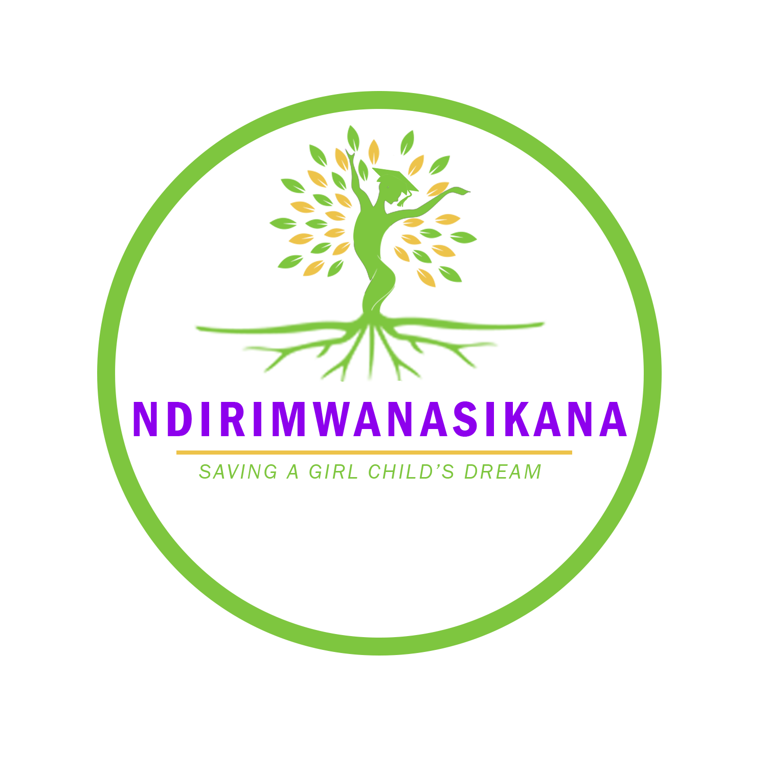
Web: ndirimwanasikana.org
Email: info@ndirimwanasikana.org
Facebook: Ndirimwanasikana
Instagram: Ndirimwanasikana_official
Twitter: Ndirimwan

LOGO: Ndirimwanasikana Logo symbolises the approach in which the organisation uses which is holistic approach.
A holistic approach means as Ndirimwanasikana we provide support that looks at the whole person, not just their mental health needs. The support we offer as an organisation also considers the girl child’s physical, emotional, social and spiritual wellbeing. Intervention is from the soil to the roots, trunk and bearing healthy positive fruits.

Table of Contents
INTRODUCTION AND BACKGROUND: 3
Organisation goal and objectives: 4
Partnerships: 5
Pad-up Zimbabwe 5
Belgravia medical centre 5
Work that has been done: 5
December 2020 5
Area of operation: 5
Beneficiaries 6
Activity areas of focus 6
Pillar 1: Providing quality education 6
School Fees and adopt a child Drive 6
Scholarship Drive 6
Access to tools and quality education 6
Pillar 2: Improving health 6
Reusable sanitary wear and masks distribution 6
Medical consultations 6
Pillar 3: Sustainable projects that generate income 7
Reusable masks and reusable sanitary wear making 7
Pillar 4: Advocacy: Raising awareness on the young girls rights 7
THE TEAM: 8

INTRODUCTION AND BACKGROUND:
A girl child is considered to be vulnerable as compared to the boy child because of many circumstances. Girls face the threat of sexual violence, gender discrimination, inequalities and child marriages that prevent them from accessing school and receiving quality education. Gender inequality, lack of basic needs and no access to resources damages the physical and mental health of millions of girls across the globe. Child poverty is a global phenomenon.
Child poverty: “Children living in poverty [are those who] experience deprivation of the material, spiritual and emotional resources needed to survive, develop and thrive, leaving them unable to enjoy their rights, achieve their full potential or participate as full and equal members of society” (UNICEF 2004).An important distinguishing feature of child poverty according to the Zimbabwe National Statistics Agency (ZIMSTAT) and UNICEF (2019) In the Zimbabwe Child Poverty Report 2019 is that children in rural Zimbabwe are far more likely to be poor than are those in urban areas. This report further gives evidence by stating that in virtually all provinces rural child poverty exceeds 70 per cent, while urban child poverty is below 30 per cent. Mashonaland Central was identified as the province which suffers from the worst rural child poverty of all Zimbabwean provinces: nearly 86 per cent of children in rural Mashonaland Central province live in a poor household, and more than 60 per cent are in a household where monthly consumption expenditure is lower than the food poverty line. (ZIMSTAT, & UNICEF, 2019).
NdiriMwanasikana is a registered non-governmental organisation founded in 2020 with the aim of eradicating child poverty and assisting under privileged girls in the rural areas starting with Mashonaland central province which has high rates of child poverty. Approval to operate in this province was granted recently and work will commence starting in Shamva as it was an area of need identified by the Provincial District Office. NdiriMwanasikana tackles these problems by improving health, providing quality education, life skills and implementing sustainable projects which utilise on the young girl’s strengths. These young girls are between the ages of 10 to 21 years who come from poor backgrounds, are orphans, young girls living with disabilities, girls who have serious health conditions or have fallen victim of natural disasters. The organisation is mainly centred on the girl child hence, the term “Ndiri Mwanasikana” which means I am a girl child. NdiriMwanasikana aims to save the girl Childs dream.

Organisation goal and objectives:
Goal:
Eradicating child poverty through empowering young girls with the necessary knowledge, skills and support in order for them to address the barriers that hinder them from living a self-sustained successful life.
Objectives:
- To provide young girls with access to education by giving them links and resources to government educational programs e.g. BEAM, scholarships and trainings on ways to do better in school so that they are able to apply knowledge in everyday life.
- To improve the health of the young girls by providing them with reusable sanitary wear, cotton underwear and access to medical facilities and teaching them about the importance of mental health and sexual reproduction.
- To incorporate sustainable projects and life training skills which will focus on the strengths of the young girl which will enable them to discover ways in which they can generate food/ income
- To ensure that all the young girls are aware of their rights through holding various awareness campaigns and holding seminars which cover a range of topics that affect the girl child the most e.g. GBV/Abuse, young marriages and Social cohesion etc.
- To liaise with other organizations and government departments in order to gain support in achieving the same goal.
- To raise and invest funds for the purpose of achieving the goal of the trust.

Partnerships:

Pad-up Zimbabwe
Pad up Zimbabwe is a local manufacturer for flo-less reusable pads that not only provides access to reusable pads but also provides health reproductive insights to young girls and women in rural areas. Pad up Zimbabwe products have met the requirements of the standard association of Zimbabwe
Partnership with pad-up is on a project aimed and empowering women and ending period poverty.

Belgravia medical centre
Belgravia medical centre has qualified doctors. As part of the pillar of improving health these doctors have agreed to not only focus on providing reusable pads but implementing a holistic approach to health, this includes: provision of medical services to the young girls, provision of medical supplies to young girls who have chronic conditions and health promotion.

Work that has been done:

December 2020
The organisation was registered in October 2020 but by December we were fortunate enough to have found donors who helps us with Christmas for the children at Tariro house of hope Epworth.
We had received donations of a lot of softly worn/ new clothes that we gave to the children. A Christmas cake was also donated by a good baker called Koti-Cakes. The Christmas lunch we held comprised of a meal with rice, braai chicken, beef stew, coleslaw, and butternut. After the lunch we gave the young girls hygiene packs which composed of: toothbrush, Colgate, tub of Vaseline, soap, deodorant and a roll on. Distribution of 80 reusable pads was also done which saw 25 girls working towards ending period poverty.

Area of operation:
As an organisation we want to provide assistance that is targeted and meaningful to areas that need help the most. After identifying Mashonaland central as being the province with high child rates of poverty we entered the community and applied for permission and access to operate in the province in January 2021.Due to covid the process was delayed. This process took time but eventually the letter from the President’s office and cabinet, and letter from the honourable Minister of state for provincial affairs and devolution granting us permission to operate was given 0ctober 2021. With the letter of approval as an organisation we got advised that the first area we should work in in Shamva as this area shows concern for more help. Ndirimwanasikana is now operating in Mashonaland Central, Shamva.

Beneficiaries
Beneficiaries of our services are young girls between the ages of 10 to 21 years who come from poor backgrounds, are orphans, young girls living with disabilities, girls who have serious health conditions or have fallen victim of natural disasters.

Activity areas of focus
Ndirimwanasikana focuses on 4 pillars

Pillar 1: Providing quality education

School Fees and adopt a child Drive
We aim to pay fees for primary and high school kids in rural areas of each province. We hope through sponsorship, partnerships with other organization’s and from fundraising activities we will be able to raise the necessary amount to be able to ensure that the young girls are able to attend school until they are finished and have all the necessary tools they need to ensure that they are doing well.

Scholarship Drive
We realize that there are many organizations and opportunities for education locally and even internationally through scholarships and grants and we would want to be able to help our beneficiaries who may qualify. We will help them with their applications and preparations as well as actually identifying any scholarships that they may be eligible for. We want to help prepare students for as far as tertiary level scholarship applications and part of our job is to identify scholarships that any of our beneficiaries would be eligible for.

Access to tools and quality education
Another aspect of our education pillar is to provide any tools that may be able to help assist our students to improve on their education. We realize some may already be in school and may have someone able to pay the school fees for them. However we ensure that they have all the tools including text books, help with homework from their older ‘siblings’, access to trainings, internet, any gadgets that could improve their school life and even access to uniforms and clothing that they need for a better and more efficient school life

Pillar 2: Improving health

Reusable sanitary wear and masks distribution
Provision of reusable sanity wear, cotton underwear and masks from Pad-up Zimbabwe

Medical consultations
Provision of medical services from doctors from Belgravia medical Centre

Pillar 3: Sustainable projects that generate income

Reusable masks and reusable sanitary wear making
In African countries learning to make reusable sanitary pads often features in the education of the young women.Our partnership with pad up Zimbabwe goes beyond just provision of reusable sanitary wear and cotton underwear but also offers educational programs on reproductive health and teen pregnancy and training in making reusable sanitary pads. With this vital education and training in making reusable sanitary pads, as well as other aspects of reproductive health, girls in each province targeted will be able to pursue their education without compromising their wellbeing

Pillar 4: Advocacy: Raising awareness on the young girls rights

THE TEAM:
TITLE NAME QAULIFICATIONS
Founder/Project  Director | Vimbainashe Matsai | Bachelor of Social Work (Psychology)  Masters in Community Development
Development Officer | Nomsa Chipokore | Bachelor of Development Studies (Hons)
Psychologist | Tiffany L.F. Shadrik | Bachelor of Psychology (Hons)

The above names stated are the leadership body. This team ensures that the organization is developing in step with its mission and organizational values, and that the organization maintains good practice in its administration and projects. The Board of Directors, Board of Trustees form this organizational leadership.
Ndirimwanasikana implements a bottom-up, participatory strategy in order to make the decision-making processes collective.

