Zimbabwe Election Support Network
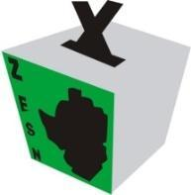
Monitoring Government Responses to the COVID-19 Pandemic
2021 Update #8

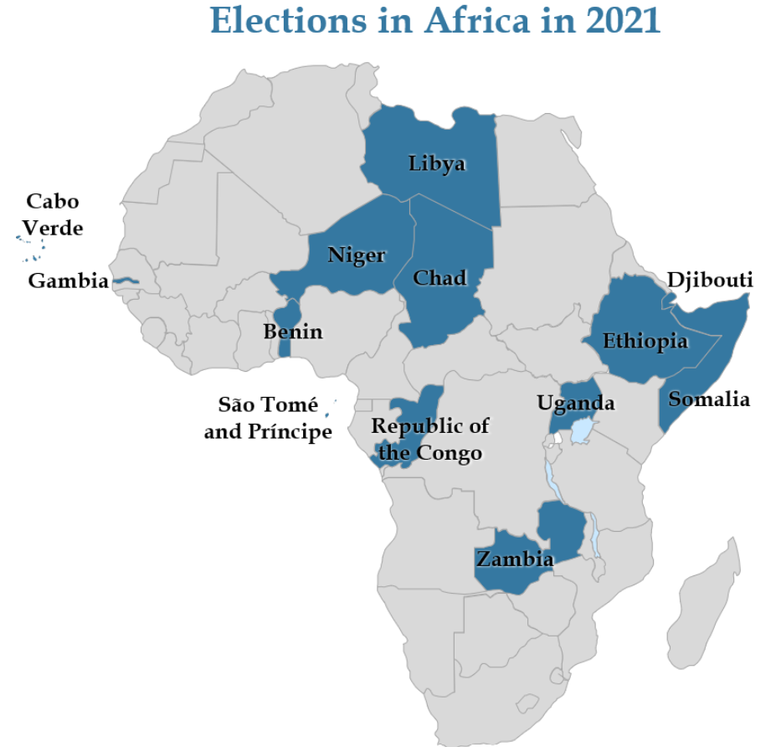

INTRODUCTION
This report covers developments that occurred in the month of October 2021, as reported by ZESN LTOs. ZESN hopes that the report will complement information available for use in the development and reinforcement of strategies aimed at safeguarding the health of citizens in the midst ofthe COVID-19 pandemic.

MINISTRY OF HEALTH SUMMARY UPDATES
As at 04 November 2021, Zimbabwe had 133 112 confirmed cases, including 127 876 recoveries and 4 685 deaths. To date, a total of 3 345 309 people have been vaccinated against COVID-19.

SUMMARY OF FINDINGS
During the period covered by the report, ZESN LTOs reported the following:

IMPACT OF COVID-19 ON THE FOOD AID DISTRIBUTION
Not many food aid interventions were reported. The Social Welfare Department gave beneficiaries 50kgs of maize in Chimanimani West Constituency.

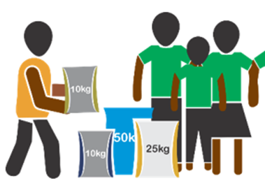
In Mufakose, GOAL gave beneficiaries $12 each. In Kwekwe Constituency, beneficiaries received USD70 COVID-19 relief funds each from Plan International.

ELECTIONS IN THE AGE OF COVID-19
LTOs reported that ZEC Provincial and District registration centres were open during the reporting period. However, reports generally show that the numbers of people who registered to vote remained low as has been the trend in previous months. Further, the number of people who turn up to register is anticipated to increase dramatically as ZEC announced that the Commission will conduct a voter registration blitz that will create 900 voter registration centres. Registration will be in two Phases, phase 1 starting on 6 December 2021 will run for 15 days, phase 2 starting on 28 December will run for 35 days.
The Ministry of Health instituted regulations whose effect among other things is to suspend by-elections indefinitely. These regulations are contained in Statutory Instrument (SI) 225A. Electoral Stakeholders were generally surprised when the deputy Minister of Health and Child Care recently said that his Ministry was not responsible for stopping by-elections as it did not have the role to supervise elections.
Selective application of COVID-19 regulations is evident in that some churches such as the African Apostolic Church have been allowed to gather in numbers in excess 16 000 congregants with the full knowledge and tacit approval by the Government as the event was covered by the State-owned media. The same church subsequently convened a much bigger gathering in the Midlands Province that was addressed by Ambassador Matemadanda.

Political Activities during lockdown
Political parties continued with activities under level two of the lockdown in the month of October.
Internal ZANU-PF primary elections were reported in many constituencies that include Goromonzi West; Goromonzi North; Muzarabani South; Marondera East; Mudzi South; Makoni West; Nyanga South; Guruve North; Binga North; Gokwe Sesame; Gokwe Nembudziya; Mudzi West; Mwenezi East; Glen View North; Chivi Central; Mutare South; Mazowe South; Magunje; Mudzi South; Gweru Urban; Insiza South; Sanyati; Kariba; Mhangura; Mabwe; Zvimba West; and Hurungwe West.
The elections were particularly reported to be violent in Kadoma Constituency where they were consequently called off in some wards. In Ward 5 of Chipinge Central Constituency, results for internal ZANU-PF elections were not announced as complaints were raised with allegations that someone who was not in the party’s structures had contested.
ZANU-PF party restructuring activities were reported in some constituencies, including Chakari; Mt Darwin West; Chiredzi North; Makokoba; Mutoko South; Goromonzi West; and Seke. The ruling party’s members were still moving from door to door capturing details of potential voters and promising handouts in Kadoma Constituency. The door to door visits were also reported in Warren Park Constituency.
ZANU-PF meetings were reported in Constituencies that include Harare East; Harare South; Goromonzi South; Masvingo North; Chikomba East; Mpopoma Pelandaba; Glen Norah; Nkulumane; Gokwe Chireya; Gokwe Gumunyu; Wedza North; and Mutare North.
On the other hand, the president of the MDC Alliance was reported to have visited constituencies that include Makoni Central; Masvingo West; Chiredzi West; and Chipinge Central as part of the tours to rural areas that he recently embarked on. He also visited Chimanimani West Constituency and could not address a gathering at Birchenough Bridge because there was no prior authorization of the gathering.
In Mutare West Constituency, ZANU-PF members received maize from Member of Parliament, Percy Muchimwe, at a cost of USD4 per 50kgs. However, some people who were gathered at Chiadzwa Business Centre are said to have rejected the offer arguing that even if the maize was to be given for free they would not accept as Muchimwe had never been seen in the Constituency since his election in the 2018 elections.
Energy Mutodi, an aspiring candidate for Bikita South National Assembly seat, donated 160 bags of cement to Njaravani Primary School in Ward 4 and 100 bags, 100 bags to Matezano in Ward 7. In Glen View North, an aspiring National Assembly seat ZANU-PF candidate gave groceries to the elderly.

Highlights of ZESN Activities
In the month of October, ZESN implemented several activities in pursuit of its mission of promoting democratic elections in Zimbabwe.
ZESN convened virtual community hall meetings in the country’s 10 provinces, on the communities’ perspectives, challenges, and opportunities for enhanced citizens’ participation in voter registration.
The network also held a virtual public meeting on the effective participation and representation of women in Zimbabwe’s electoral democracy. The network continued with weekly local or community radio programmes broadcasted on Breeze Radio in Victoria Falls and 98.4 in Midlands Province, focusing on different election-related issues, including the role of the church and community-based organisations in voter registration and the importance of youth and women’s participation in voter registration. ZESN also widely distributed copies of its Ballot Newsletter.
ZESN held meetings with Parliamentarians who sit in the Portfolio Committee on Justice, Legal and Parliamentary Affairs to discuss clauses of a proposed Comprehensive Electoral Amendment Bill that ZESN and other CSOs drafted which was presented to Parliament.
The network also held meetings with its clusters that include organisations representing women, youth, and people with disabilities and met its provincial taskforces to discuss current election-related developments around the country, as well as future programming.
ZESN attended ZEC’s stakeholder’s engagement meeting with other CSOs which provided an opportunity to discuss the upcoming voter registration blitz and Boundary Delimitation processes.
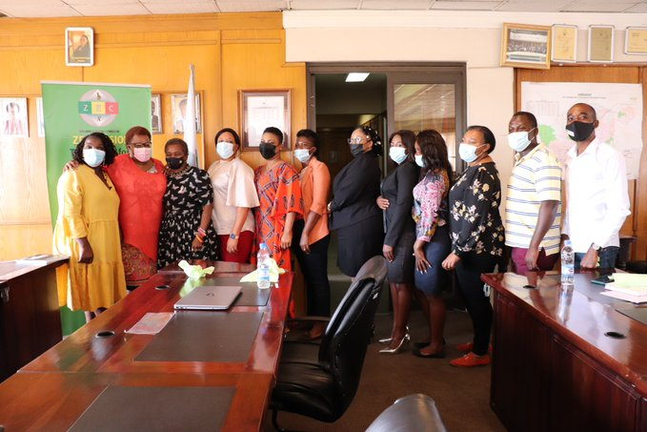
Picture 1: Part of the CSO representatives that attended the ZEC-CSOs' meeting
ZESN convened a capacity building workshop for CSOS whose aim was to enhance understanding of the candidate nomination process, the challenges encountered by aspiring electoral contestants in adhering to the set requirements, opportunities for improving the process and what reforms would be required. ZEC assigned a senior officer (Deputy Chief Elections Officers-Operations) to serve as a resource person at the workshop. In keeping with the ZEC stakeholder engagement strategy, the resource persons stayed throughout the workshop to provide clarity and responses to questions directed at the work of the ZEC.
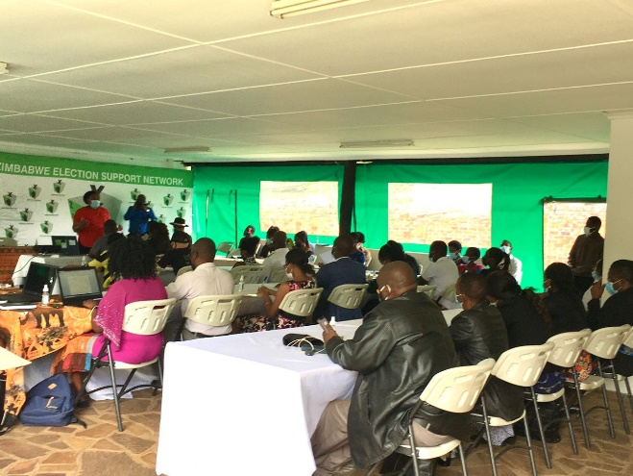
Picture 2: Participants at the capacity building workshop on nomination process.
The network also participated in Youth Summits on youth participation in 2023 harmonised elections organized by the Zimbabwe Council of Churches in Mashonaland East province.
A Virtual Public meeting was held during the reporting period which explored strategies that can help enhance women’s participation in elections. The Zimbabwe Gender Commission’s Chief Executive Officer and a ZEC Commissioner were part of the panel of five presenters.
As part of ZESN efforts to provide continuous electoral education ZESN produced and distributed its Ballot Newsletter which contains a range of articles on electoral developments. Physical and electronic copies were distributed. The distribution strategy for the Newsletter includes handing the copies to passengers on buses that service routes that pass through hard to reach rural areas, as well as CSO partners with outreach activities in different urban and rural communities. Volunteers at busy urban bus terminus have also supported the Newsletter distribution. Through these efforts, 30,000 copies of the Newsletter were distributed in October.
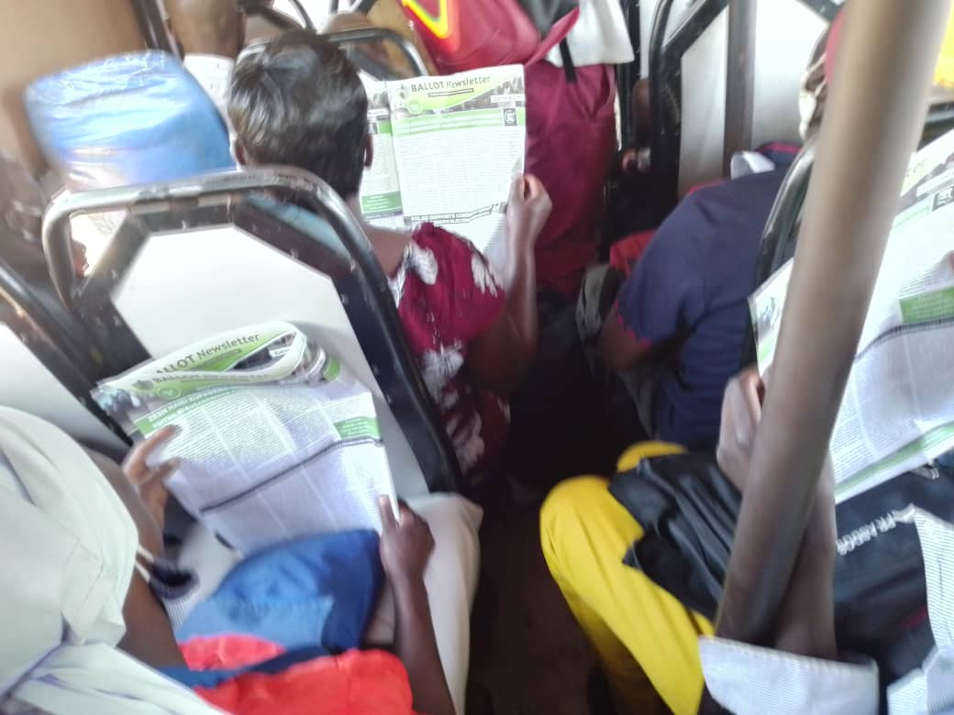
Picture 3: Passengers in a bus headed for Chiredzi, reading the ZESN newsletter.

RECOMMENDATIONS
- All eligible Zimbabweans should take the opportunity presented by continuous voter registration and register to vote at ZEC’s district and provincial offices as well as at the additional centres that will be used during the upcoming VR Blitz.
- Government should lift the ban on by-elections and have ZEC conduct by-elections with strict observance of COVID-19 protocols.

https://twitter.com/MoHCCZim/status/1456401487018483725
https://www.newzimbabwe.com/chiwenga-suspends-by-elections-indefinitely/
https://www.newsday.co.zw/2021/10/were-not-responsible-for-by-election-delays-mangwiro/
https://www.herald.co.zw/paul-mwazha-celebrates-103-years/
https://www.herald.co.zw/govt-to-honour-clergymen/

