MASVINGO LOCKDOWN MONITORING
27 APRIL 2020
Lockdown measures are continuing throughout Masvingo however residents and stakeholders are expressing concerns over failure by law enforcement agencies particularly the Zimbabwe Republic Police to enforce simple measures across supermarkets. It is mandatory for all supermarkets to have hand washing spots and or hand sanitizing points at their entrances however police that mann supermarkets are not enforcing these measures and this has seen an increase in shops that are not complying thus putting Masvingo residents at Risk. In Ward 7 in Masvingo Rural each supermarket is manned by five (5) police officers but residents were complaining that they seem not to be concerned with enforcing lockdown measures and this has led to the complains by law abiding citizens against the law enforcement agencies. The Zimbabwe United Passenger Company (Zupco) is also the only company that is carrying commuters for essential work and services across Masvingo with only very few people being allowed to board a bus at a particular interval , while this is commendable this has exposed commuters to long hours to idle waiting for transport services due to the fact that Zupco buses are limited as such residents of ward 9 in Masvingo are urging the government to increase the number of Zupco busses that service routes in order to limit the time people wait for buses
EVIDENCE: The entrance of a local Supermarket in Victoria Range Masvingo with no hand washing or sanitizing points. & commuters in ward 9 boarding Zupco buses.
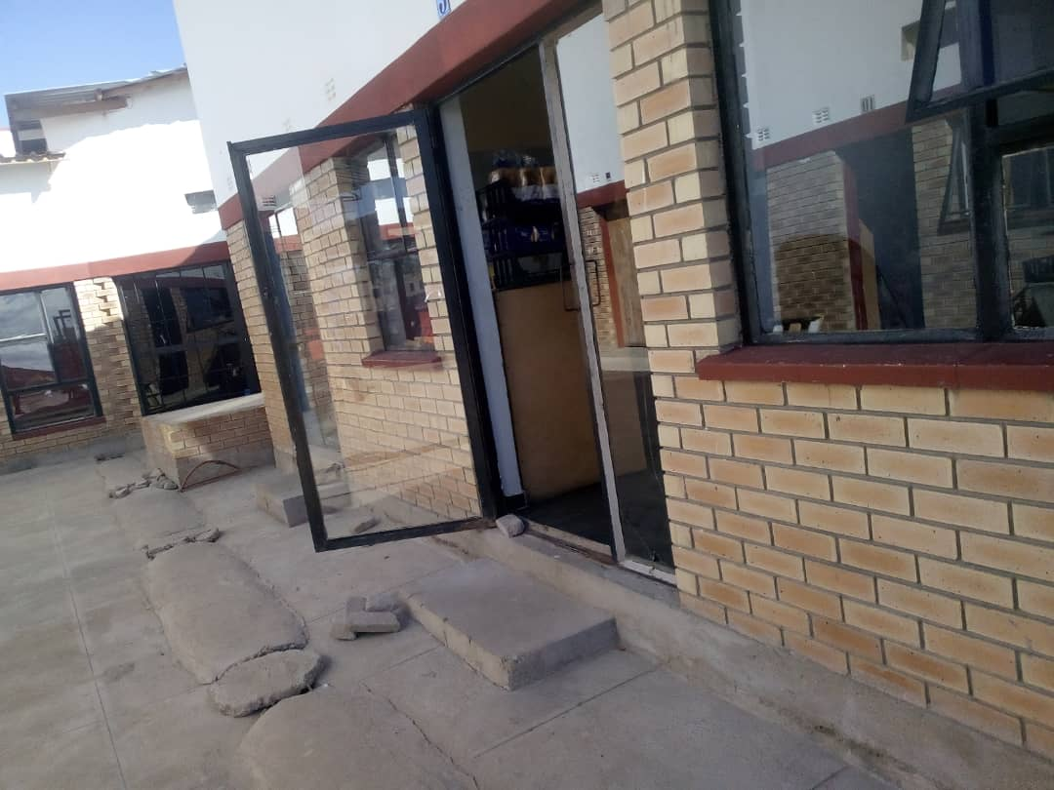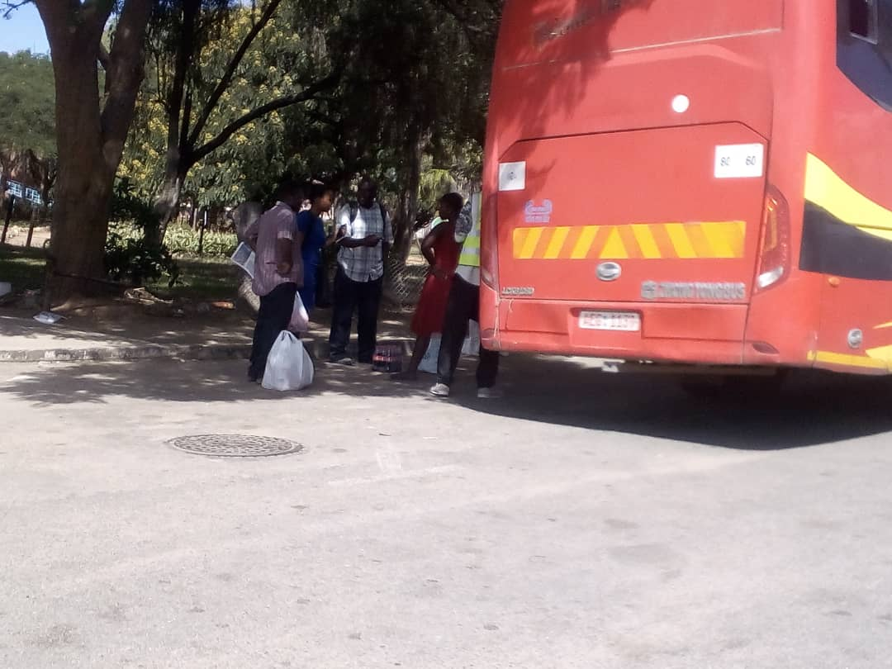
Masvingo city town council and the District Civil Protection Committee are also doing thier best to ensure that Rujeko Isolation Centre is completed at the shortest time possible. The isolation center will be serving all COVID 19 Patients from across the seven districts of Masvingo Province. Structural works have been completed with only final touches remaining this has been due to the support the local authorities are getting from business individuals and civil society organizations across Masvingo Province.
EVIDENCE: progress on the RUJEKO Isolation Centre in Masvingo’s Rujeko Suburb.
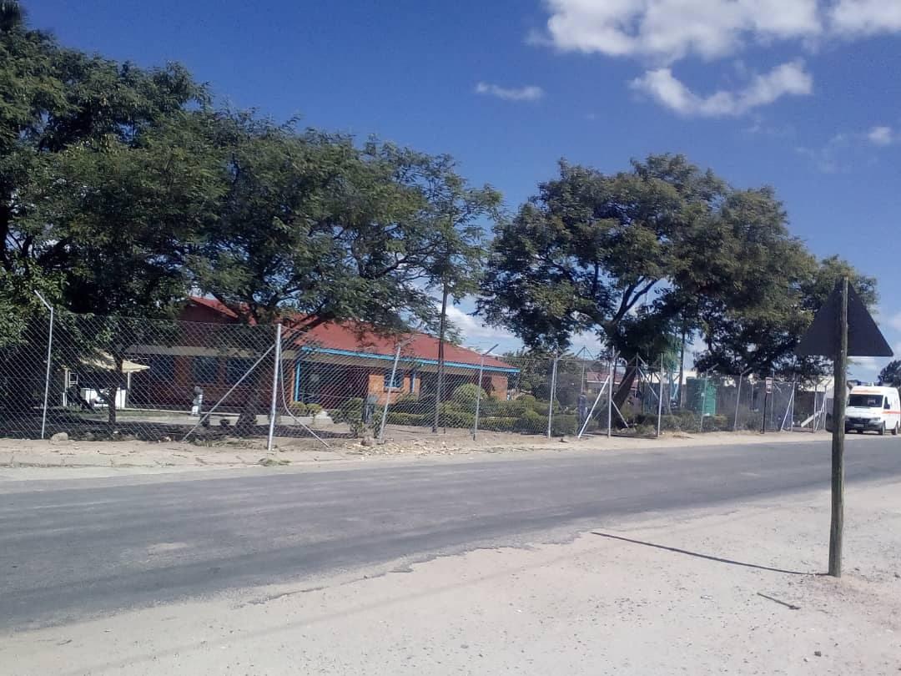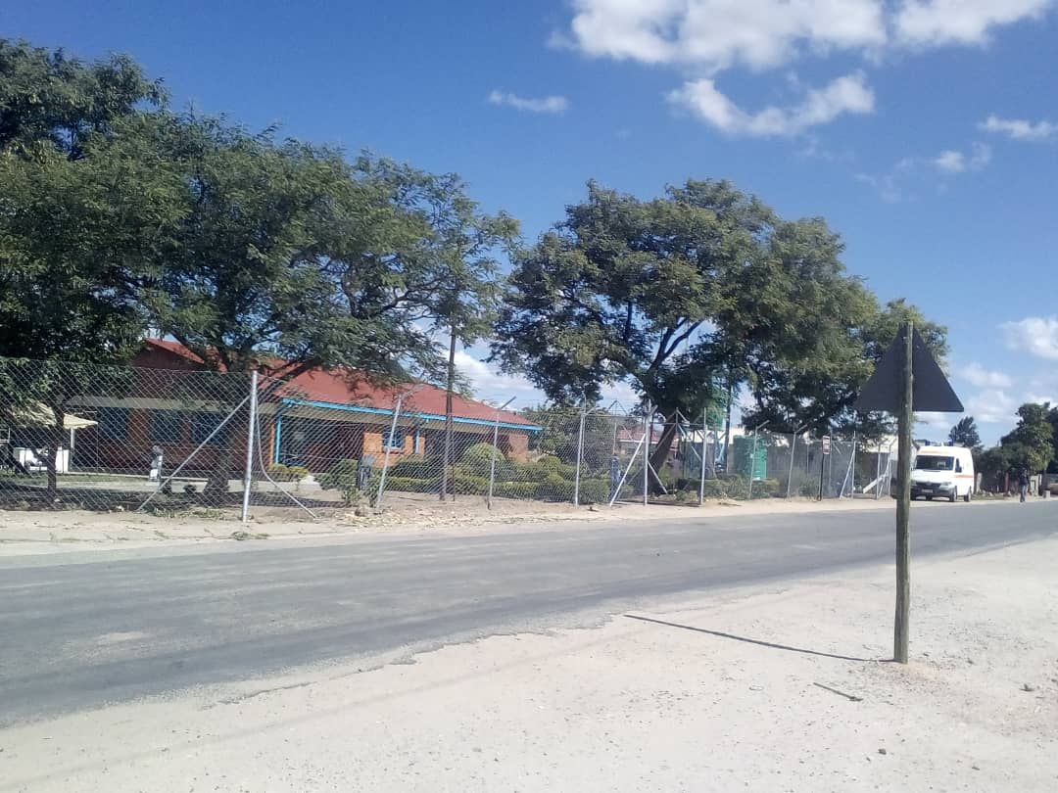
Runyararo and Mazorodze clinics open from 9am – 3pm to provide health care to the community members and suspects of COVID 19 are going to be handled at Rujeko clinic once completed.

