ZIMBABWE ELECTION SUPPORT NETWORK BY-ELECTION

11 May 2019
© zesn 2019

MUTASA RURAL DISTRICT COUNCIL WARD 10 BY-ELECTION REPORT

Table of Contents
1. EXECUTIVE SUMMARY 2
2. ABOUT ZESN 3
3. PROFILE OF MUTASA RURAL DISTRICT COUNCIL WARD 10 3
4. BACKGROUND TO THE BY-ELECTION 4
5. CANDIDATES IN THE BY-ELECTION 5
6. NOMINATION COURT SITTING AND RESULTS 5
7. POLITICAL CAMPAIGNS 5
8. PRE-ELECTION ELECTORAL MALPRACTICES 7
9. VOTER REGISTRATION 8
10. ELECTION DAY PROCEEDINGS 8
11. COUNTING AND RESULTS COLLATION 9
12. POST ELECTION OBSERVATIONS 10
13. Conclusion 11
14. Recommendations 11

EXECUTIVE SUMMARY
In line with its mission to promote democratic electoral processes in Zimbabwe, the Zimbabwe Election Support Network (ZESN) observed the Mutasa Rural District Council (RDC) Ward 10 by-election held on Saturday 11 May 2019. The Ward is found in Mutasa Central Constituency in Manicaland Province. The seat fell vacant following the arrest and sentencing of the incumbent MDC Alliance councillor, Frank Chitembwe. Chitembwe was later granted bail when the Nomination Court had already sat. A court application filed by Chitembwe to try and stop ZEC from conducting the by-election was unsuccessful. Three candidates: Margaret Tindirika of the Zimbabwe African union Patriotic Front (ZANU-PF); Rose Tanyaradzwa Mukodza of the Movement for Democratic Change (MDC) Alliance; and Justin Tanyaradzwa Chirimo of the National Constitutional Assembly (NCA) contested in the by election that was won by the MDC Alliance. The ZANU-PF and MDC Alliance candidates were female while the NCA candidate was male.
ZESN deployed a Long Term Observer (LTO) to observe election-related developments in the period leading to, during and after the by-election and after the election. Short Term Observers (STOs) were deployed to cover all the six polling stations and the Ward Collation Centre on Election Day. The pre-election period recorded some cases of vote buying and intimidation by ZANU-PF and traditional leaders, and an incident where MDC Alliance supporters threw stones at the house of someone they accused of lying that the former Councillor, Frank Chitembwe, had blocked roads during the January 2019 protests that happened in parts of the country. There were also incidents of the defacing of campaign posters. ZANU-PF and the MDC Alliance actively and visibly campaigned using rallies; roadshows; door to door visits; posters; and fliers while the NCA’s campaign was much less visible.
On Election Day opening, polling, and counting procedures were followed in accordance with the law. However, some incidents of attempts by ZANU-PF activists to try and influence how voters cast their ballots were reported. Some voters were told to feign illiteracy and would be accompanied to polling stations so that they would be assisted to vote. In some cases voters were redirected to other polling stations. Overall, a few voters were turned away without being allowed to vote on account of not being registered. The by-election recorded the highest turnout (at 68%) of the seven local authority by-elections held since the harmonised elections. Nevertheless, as with all the other by-elections, this turnout was less than the 86% recorded for the same Ward in the harmonised elections. The MDC Alliance retained the seat with its candidate garnering 801 votes. The ZANU-PF candidate got 548 votes while the NCA candidate got 16 votes. A comparison of votes received by the MDC and ZANU PF in the harmonised elections reveals that, the MDC Alliance lost 480 votes and ZANU-PF gained 97 more votes.
Post-election, ZESN received reports of statements reportedly made by ZANU-PF supporters to the effect that the drilling of a borehole that started on Election Day at Masere Business Centre would stop. There were also reports of the politicised distribution of food aid with MDC Alliance supporters being denied food aid. Among other things, ZESN recommends that political parties and supporters engage in peaceful political activities and desist from violence and intimidation; political parties must urge their supporters to desist from destroying campaign materials for rival parties; and traditional leaders to desist from partisan conduct.

ABOUT ZESN
ZESN was formed in the year 2000 and is currently a coalition of 36 Civil Society Organizations (CSOs). The major focus of the network is to promote democratic processes in general and free and fair elections in particular. ZESN is the secretariat of the Electoral Support Network of Southern Africa (ESN-SA) and is a member of The Global Network of Domestic Election Monitors (GNDEM).
As part of its comprehensive efforts to observe the local authority by-election in Ward 10 of Mutasa RDC in Mutare province and following an invitation by the Zimbabwe Electoral Commission (ZEC), ZESN deployed 6 polling station-based observers and a Ward collation centre observer. Prior to the election, ZESN had an LTO who closely tracked electoral developments during the pre-election period, the electoral and post-election period. In addition, a mobile team was deployed to assess the political environment around the Ward on Election Day.
ZESN election observation methodology is informed by the Constitution of Zimbabwe and electoral laws of the country. The network is independent in its findings and conclusions. In addition, ZESN’s assessment of the election is also guided by a number of regional and international conventions and declarations which Zimbabwe is signatory to, such as, the SADC Principles and Guidelines Governing Democratic Elections, the African Charter on Human and Peoples' Rights (ACHPR), the International Covenant on Civil and Political Rights (ICCPR), and the Universal Declaration of Human Rights (UDHR). ZESN is also guided by the GNDEM’s Declaration of Global Principles for Nonpartisan Election Observation and Monitoring by Citizen Organisations, Code of Conduct for Nonpartisan Citizen Election Observers.

PROFILE OF MUTASA RURAL DISTRICT COUNCIL WARD 10
The Ward is one of the 12 found in Mutasa Central Constituency under Mutasa RDC in Manicaland Province. The Ward falls in a rural constituency where people survive on subsistence and small-scale commercial farming. Schools in the Ward include Honde Mission; Jombe Primary and Secondary Schools; and Samaringa Primary and Secondary Schools. The Ward had the second highest number of pupils after Ward 11, in terms of primary school enrolment in 2016. Some of the health centres in the Ward, Samaringa and Honde Mission clinics, did not have adequate facilities required for a standard rural clinic. There have been reports of the shortage of doctors at Hauna Hospital close to the Ward. The Ward was one of the two that did not have animal health facilities as of 2016. Currently, there is a challenge of water shortages in the Ward. For the 2018 harmonised elections, the Ward had a total of 2035 registered voters which reduced to 2004 in the by-election.
The map below depicts the Mutasa RDC Ward 10:
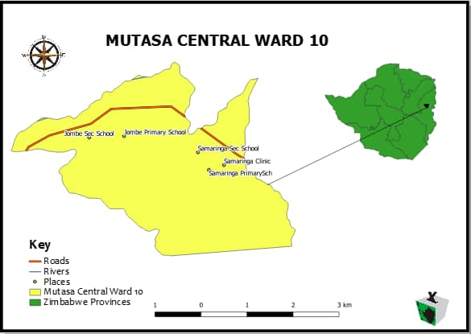

BACKGROUND TO THE BY-ELECTION
The Mutasa RDC Ward 10 seat was announced vacant following the conviction of the incumbent, Frank Chitembwe, of the Movement for Democratic Change (MDC) Alliance who won in the harmonized elections. Notification for the by-election was given in terms of section 125(4) of the Electoral Act [Chapter 2:13]. Chitembwe was charged with public violence in the protests that happened in parts of the country between 14 and 16 January, 2019 and was sentenced to a two-year jail term before being granted bail pending appeal. The Nomination Court had already sat by the time Chitembwe was granted bail. The election went on to be held as scheduled after an urgent application filed by Chitembwe to seek to stop the ZEC from conducting the by-election, which was opposed by Mutasa RDC Chief Executive Officer, was dismissed by a Mutare High Court Judge.

CANDIDATES IN THE BY-ELECTION
Women participation in elections has always been one of the central issues in democratisation. Women have historically participated more as voters than candidates owing to several constraining factors. ZESN has made repeated calls for political parties to deliberately facilitate the participation of women as candidate in elections. In the by-election, ZANU-PF and the MDC Alliance fielded female candidates while the NCA candidate was male. During the 2018 harmonised elections, two male candidates contested the Ward election. The candidate who contested in the by-election on a ZANU-PF ticket is formerly MDC and lost to the outgoing MDC Councillor, Frank Chitembwe, in the party’s 2013 primary elections before joining ZANU-PF. ZESN commends political parties for the decision to field female candidates in the by-election.

NOMINATION COURT SITTING AND RESULTS
The Nomination Court sat on Tuesday 2 April, 2019 to consider nominations for election to the office of councillor for Ward 10 of Mutasa RDC. Three candidate, namely Rose Tanyaradzwa Mukodza of the MDC Alliance; Justin Tanyaradzwa Chirimo of the National Constitutional Assembly (NCA); and Margaret Tindirika of the Zimbabwe African National Union-Patriotic Front (ZANU-PF), successfully filed their papers and were therefore duly nominated. Six polling stations were used in the by-election. The table below lists the polling stations:
Polling Station | Facility
Gombazvikara B/C | Tent
Honde Mission School | School
Jombe Secondary School | School
Samaringa Dip Tank Tent | Tent
Samaringa Primary School | School
Saruwaka B/C Tent | Tent

POLITICAL CAMPAIGNS
Political parties’ campaign activities took the form of rallies; roadshows; door to door campaigns; as well as posters. ZANU-PF and the MDC Alliance actively campaigned while the NCA’s campaign seemed only limited to putting posters in the ward. ZESN received reports of two ZANU-PF rallies and one MDC Alliance rally. The two ZANU-PF rallies were held on 21 April 2019 at St Peters Jombe Secondary School and Masere Business Centre while the MDC Alliance held a at Masere Business Centre on 08 May 2019. Party National Chairperson and Minister of Defence and War Veterans, Oppah Muchinguri and Patrick Chinamasa addressed one of the ZANU-PF rallies where road rehabilitation; construction of bridges; drilling of boreholes; reopening of Honde Valley vocational school to impart skills on women and youths; and promotion of entrepreneurship projects in the area were promised. The ZANU-PF National Assembly candidate in the 2018 harmonised elections who lost in the contest, Jefter Kuziwa Sakupwanya, also attended and addressed the rallies.
The MDC Alliance rally was addressed by party vice president, Morgan Komichi, representing party president, Nelson Chamisa, who was scheduled to address the rally. The message at the rally was on the need for electoral reforms; security sector reforms; and the need for vote buying to stop. The rally was preceded by a roadshow held around the venue where party supporters were beating drums along the way. The MDC Alliance also campaigned by way of initiating discussions about the prevailing economic hardships wherever people were gathered as well as through door to door campaigns.
On the day that the MDC Alliance held its rally, village heads mobilised people to gather and receive food aid. ZESN could not confirm the source of the food aid. Jefter Kuziwa Saruwaka addressed the gatherings at different centres that include Jombe Secondary School and Honde Mission. On the same day, ZANU-PF supporters were also celebrating a bus that had just started plying to and from the area following a promise by the Minister of State for Manicaland Provincial Affairs, Dr Ellen Gwaradzimba, who had visited the area two days earlier.
The pictures below show MDC Alliance and ZANU-PF supporters at rallies:
MDC Alliance supporters gathered at Masere Business Centre waiting for the rally to start

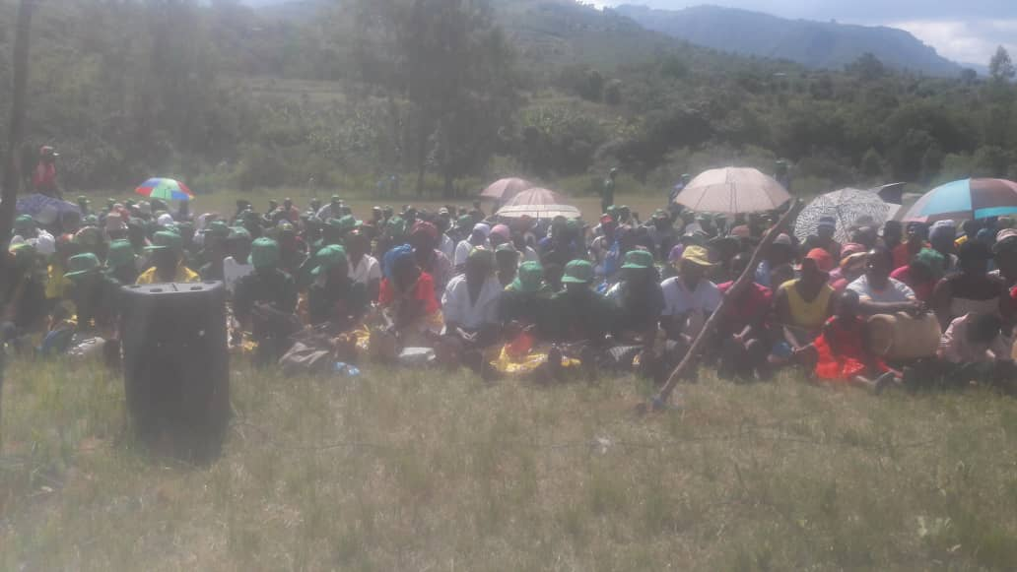
ZANU-PF supporters gathered at a rally at Masere Business Centre

PRE-ELECTION ELECTORAL MALPRACTICES
ZESN received worrying reports of intimidation and coercion and the threat of the withholding of food aid instigated by traditional leaders. These acts were targeted at supporters of political parties opposing ZANU-PF.
- Intimidation
ZESN observers reported on acts of intimidation that were perpetrated by village heads who threatened to banish villagers from their areas should they not vote for ZANU-PF and party youths who would reportedly threaten violence and that the soldiers would be deployed to beat people if they did not vote for ZANU-PF. The youths would reportedly warn voters to vote ZANU-PF to avoid a war such as that experienced in the ‘Hwahwazhira Mountains’ – a reference to the experience in the area during the liberation struggle. ZANU-PF activists in party regalia were also reported to have moved from homestead to homestead noting down names and national ID numbers of residents on the pretext that they wanted to give them food aid. Supporters of the MDC Alliance reportedly threw stones at the house of someone they accused of lying that convicted former Councillor, Frank Chitembwe, blocked roads during the stay away. Campaign posters for candidates of all the three parties were torn by suspected opposing party supporters.
ZESN denounces the above-mentioned conduct by both ZANU-PF and MDC-T supporters, as well as the traditional leaders, which contravenes the electoral code of conduct.
- Vote buying
In campaigning for the by-election, ZANU-PF supporters in the Ward linked service provision to the election of their candidate. Buses plying routes in the ward were promised in the event that the ZANU-PF candidate won the election. The distribution of food aid on 8 May was also perceived as an attempt at vote buying particularly as gatherings were addressed by Jefter Kuziva Sakupwanya who was the National Assembly candidate for ZANU-PF in the 2018 harmonised elections.

VOTER REGISTRATION
Section 17A of the Electoral Act (Chapter 2:13) provides for voter registration. In terms of the law, voter education should be continuous. The number of registered voters for Ward 10 in the by-election reduced to 2004 from 2035 in the 2018 harmonised elections. The voters’ roll cleaning process resulted in some changes, for example, based on their villages of residence, some voters were assigned to polling stations different from the ones they voted in during the 2018 harmonised elections. In the absence of communication, negative perceptions about election administration can easily intensify. ZEC therefore needs to make sure that it communicates in instances where crucial information is needed, for example notifying voters whenever their registration changes by the reassignment of polling stations in-between elections.

ELECTION DAY PROCEEDINGS
  - Set up and opening of polling stations
All polling stations in the by-election were set up on time, in accordance with laid down procedures with ballot booths set up in such a manner that voters could mark their ballots in secrecy. All the essential voting materials such as ballot boxes, ballot papers, ZEC stamp, indelible ink, a biometric voters’ roll with pictures were reported to be available at all polling stations. Commendably, polling stations were also accessible to people with disabilities such as wheelchair users and voters of short stature.
  - Voting process and procedures
The voting process at all polling stations proceeded smoothly with procedures such as showing ballot boxes to be empty, checking voters’ names against the voters’ roll, examining voters’ fingers for indelible ink and applying the ink being duly followed. Observers also reported that all voters were required to present identification documents before voting.
  - Election Agents
Political parties and candidates contesting in an election are allowed three agents on Election Day; one inside the polling station and two outside the polling station. Commendably, all the political parties that contested in the by-election deployed agents to all the six polling stations. ZESN applauds the political parties and candidates for investing in the deployment of agents as this enables them to observe and authoritatively comment on the polling processes.
  - Malpractices
While no incident of violence was recorded on Election Day, there were allegations of the presence of party activists close to polling stations attempting to influence voters, including by intimidation, to vote for ZANU-PF. This was reportedly the case at Honde Misssion and Jombe Primary School in particular. ZESN also condemns the behaviour of MDC Alliance and ZANU-PF supporters who caused commotion at Masere Business Centre where the later resisted attempts by an MDC Alliance vehicle to ferry a voter to a polling station to cast her vote. There were also instances where voters would be asked to feign illiteracy so that they could be assisted to vote. In two reported cases, the women involved finally voted on their own after insisting that they did not require assistance. In both cases, suspected ZANU-PF activists had followed the women to the polling stations to assist them to vote. A borehole was also drilled on Election Day at Masere Business Centre in an act perceived as an attempt at vote buying especially after there were threats to stop the drilling after the election in which ZANU-PF lost. These acts are in contravention of the Code of Conduct for Political Parties, Candidates, and other Stakeholders.
  - Voter turnout
It is encouraging that voter turnout was higher in this by-election than in other by-elections held earlier. The by-election recorded a 68% voter turnout. The long queues that were observed in the morning disappeared during the course of the day. More women than men were seen in the queues and youth turnout was particularly low when compared to other age groups. The overall turnout was however lower than the 86% voter turnout recorded in the harmonised elections.
Queues of voters waiting to cast their ballots at Honde Mission (right) and Gombazikara Business Centre Tent (left)

COUNTING AND RESULTS COLLATION
At all polling stations, ZESN observers were permitted to observe counting and results collation. Closing and counting procedures were duly followed including checking the seals on ballot boxes, requesting election agents to sign V11 forms and affixing results outside polling stations.
The MDC Alliance candidate, Rose Tanyaradzwa Mukodza, was duly elected as the Councillor of Ward 10 of Mutasa RDC having garnered 801 votes. The MDC Alliance therefore retained the seat it won during the 2018 harmonized elections. The ZANU-PF candidate got 548 votes while the NCA candidate got 16 votes. In the 2018 harmonized election, the MDC Alliance won with 1281 votes while ZANU PF candidates received 451 votes. The 2019 Ward 10 by-election results and the 2018 harmonised election results are shown in the table below:
2018 HARMONIZED ELECTIONS RESULTS |  |  |  |  | 2019 BY-ELECTION RESULTS
Candidate | Sex | Political party | Votes |  | Candidate | Sex | Political party | Votes
Chitembwe Frank | M | MDC Alliance | 1281 |  | Mukodza Rose Tanyaradzwa | F | MDC Alliance | 801
Matingo Michael Simon | M | ZANU-PF | 451 |  | Tindirika Margaret | F | ZANU-PF | 548
 |  |  |  |  | Chirimo Justine Tanyaradzwa | M | NCA | 16
Valid Votes Cast | 1732 |  |  |  | Valid Votes Cast | 1365
Votes Rejected | 12 |  |  |  | Votes Rejected | 4
Total Votes Cast | 1744 |  |  |  | Total Votes Cast | 1369
Voter Population | 2035 |  |  |  | Voter Population | 2004
Percentage Poll | 86% |  |  |  | Percentage Poll | 68%
SOURCE: ZEC

POST ELECTION OBSERVATIONS
In the post-election period, ZESN received reports that there were statements to the effect that the drilling of a borehole that had started at Masere Business centre on Election Day would stop. The impression from the pre-election campaigns was that the project was ZANU-PF-led. At the time of writing this report, though the equipment is still on the site, the drilling has stopped with fuel shortages being cited as a challenge. There were also reports of the politicisation of food aid where that MDC Alliance supporters were reportedly denied food aid at Honde Mission on 13 May 2019.

Conclusion
In line with its mission to promote democratic electoral processes in Zimbabwe, ZESN condemns the electoral malpractices that happened in Mutasa RDC Ward 10 ahead of the by-election and the allegations of attempts to interfere with the choice of voters on Election Day. ZESN urged political parties and traditional leaders to desist from engaging in conduct that contravenes the Code of Conduct for Political Parties, Candidates, and Other Stakeholders, and the Traditional Leaders Act [Chapter 29:17], respectively.

Recommendations
Based on its observations, ZESN proffers the following recommendations:
- Political parties and supporters should engage in peaceful political activities and desists from engaging in violence and intimidation;
- Political parties must urge their supporters to desist from destroying campaign materials for rival parties;
- Traditional leaders to desist from intimidation and partisan conduct;
- Political parties should desist from vote buying and politicisation of aid.

Mutasa Central Constituency Profile, Parliament of Zimbabwe 2016
Mutasa Central Constituency Profile, Parliament of Zimbabwe 2016
Mutasa Central Constituency Profile, Parliament of Zimbabwe 2016
Mutasa Central Constituency Profile, Parliament of Zimbabwe 2016

