Institute for Public Affairs in Zimbabwe (IPAZ) GravitasLite: False Transitions Special Edition

28.11.2017 Contact: gravitas@ipazim.com

Dangerous seasons of our unreason: Spectacles, Specters and the Gulag

Tinashe L. Chimedza and Tamuka C. Chirimambowa*

Political events in Zimbabwe have moved intensively and quickly with very far reaching consequences. Taking advantage of army apparatchiks that were keen to resolve ZANU PF’s factional infractions the povo prized open this neurotic gulag we have been calling a country. And what a mess it is. The keys to the gulag were forcibly taken over by those who have been worse jailers before. This is the point where we say we are now living in the dangerous season of unreason. Political sands are shifting. All what we thought was ‘solid is melting’ at the altar of new allegiances. Some in the prodemocracy movement are dreaming of another ‘transitional authority’ of sorts, but the answer has been swift and disarming: ‘this is a ZANU PF victory’. These intellectual flights of fancy are a national reflection of the rate at which even those who are at the apex of the alternative social democracy project can easily be swept up by temporary sentiment. The beauty of our young constitutional republic is that the people's will is reposed in parliament and it is composed of different political parties to ensure accountability of sorts. To continuously disturb this beauty by always having a ‘government of unity’ is a non-progressive hallmark of defeating multiparty democracy. It will be a gravedigger of our young republic.

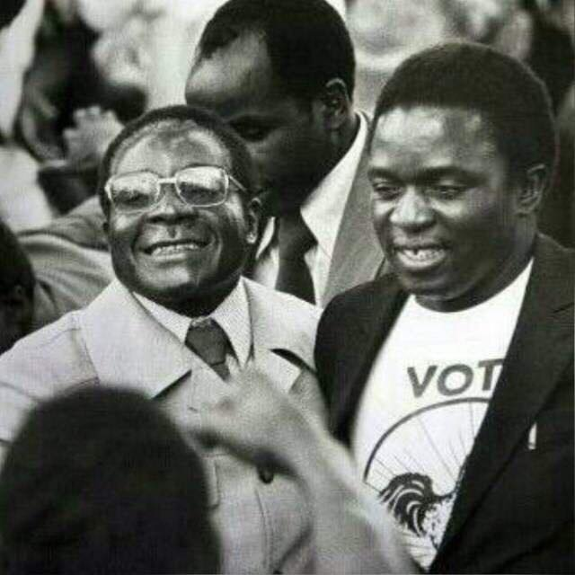

Fig 1.0 Mugabe is my mentor and father: ED

Listening to new President Emerson Mnangangwa preaching about ‘unfolding democracy’, ‘leadership succession’, ‘economic recovery’ and ‘international re-engagement’ a stranger from another planet would think that Zimbabwe has been hiding a Mandela in the dungeons of police prisons at Goromonzi. Even with the dazzling speed at which the drama has unfurled itself we still need to maintain perspective: to analyze Mugabe here and Grace from another corner; to then take the Generals and the new President in another corner and then try and deconstruct the citizen’s action in another corner is simply an intellectually lazy and politically senile euphoric endeavor. We must see the political contestations in their totality and also in their potentiality. On the 18th of November the genie of people’s power was let out of the cauldron of repression and any ‘elite pacts’ will only be short sighted attempts to put it back into the bottle. That is our basic argument.

E.D Mnagagwa Repackaged: shadows and specters of history

The new President, ED for some, has been both an architect and a beneficiary of the subversion of the democratic processes in Zimbabwe going back to the 1980s and more recently in 2008 election. If indeed the ‘voice of the people is the voice of God’ then surely the people have been speaking loudly and clearly rejecting ZANU PF at the polls. ED is a Trojan horse of what others have called the ‘deep state’ which was very desperate to reproduce itself and its elite network. The ballot box has always presented a threat to a network of elites who have looted Zimbabwe dry and have been party to these ‘treacherous shenanigans’ as others have said. The hierarchical party-

state apparatus built by the ruling elites steam-rolls on its opponents extra-legally and extra-judicially. To start to imagine that ED has suddenly become a reformer and a democrat goes to show the level of political disorientation currently fashionable. It is bound to unravel.

For all the sound, frothing fury and revolutionary theory that the War Vets project to think that with that level of analysis they mistook Mugabe for a revolutionary since 1976 stretches our imagination too far. This is a Public Relations exercise. It is a charm offensive meant to hoodwink the citizenry. Some sections of the opposition are already groveling at their feet in anticipation of a few elite crumbs. Opportunism galore. When civil society was demanding security sector reform it meant a reform of the very institutions that ED had been an architect of. His name is allegedly imprinted on the many negative episodes of our history: From Gukurahundi to the Democratic Republic of Congo; from the network of ZANU PF companies now defunct to the diamond fields of Chiadzwa; from the Joint Operations Command (JOC) and operations undertaken since 2000 and to the subversion of the people’s will in the 2008 elections. This is the Emerson Mnagangwa we had become accustomed to. He has been nicknamed the ‘crocodile’ not for hunting in the animal kingdom.

‘Neo-liberalism’ and the ‘Chinese Model’: Geo-political Scrambles

Harare rumor mill has it that the Chinese hand was very visible in the ‘corrective army action’ and the Minister for Africa from the UK flew in rather very quickly. UK Ambassador Laing was as usual blushing when she saw the ‘croc’ being sworn in. Zimbabwe needs another ‘strongman’ not democracy has been the UK entry point of late. We are about to witness a new scramble in Zimbabwe as opportunities by the ‘new’ political regime seems to have reignited some intense geo-political maneuvering. The question that will be answered very soon is: which economic model does Zimbabwe pursue after the re-arrangement of chairs in the cockpit? Takura Zhangazha has argued that Zimbabwe risks to have a ‘permanence of elite politics’ and Professor Patrick Bond warned about Zimbabwe’s unending ‘elite transitions’. This is a reality that must interrogated.

‘Comrade’ Chris Mtsvangwa is out of the gates already charging that ED will be ‘Zimbabwe’s savior’ and that he must pursue the Chinese model developed under Deng Xiaoping. That model was an economic transformation with deep structural industrialization impact but this was achieved with a very authoritarian one-party state. The Deng Xiaoping concoction of economic transformation without democratic reform ended in the 1989 student revolts, tanks on the streets and the infamous Tiananmen Square massacre. The other extreme is the Thatcherite/Reaganomics (Eddie Cross?) type of global political economy casino economics which came down tumbling in 2008-2009. One economist very near the Office of President and Cabinet has been pushing that the government must dispose some parastatals for a nominal $1.00 in exchange of new capital injections. Zimbabwe faces the crippling triple crisis of ‘poverty, inequality and unemployment’ as consequence of a non-productive economy which has been fashioned as an ‘enclave economy’ and has not be structurally reformed.

Tendai Biti has argued, and we have done so in the past, that Zimbabwe has to search for solutions in the democratic developmental state. Kanyenze et al (2017) have recently published a good starting point: Towards the Developmental States in Southern Africa (Weaver Press). On Zimbabwe specifically there is another good read by Kanyenze etc al (2011) ‘Beyond the Enclave’ (Weaver Press). The points argued for in these texts is that ‘democracy’ and ‘development’ can not be decoupled especially as pushed for by the militarists in the Chinese model and also the extreme ‘free market’ illusions that failed spectacularly with Structural Adjustment Programs in the 1990s.

Change without transformation: Yoda Strikes Back

In a movie called Gladiator there is an intriguing scene about the succession muddles when the Roman Emperor is slain by his own son. Russell Crowe, acting as a deposed General called Maximus Decimus Meridius who escaped assassination, is in the company of an old gladiator Proximal who gives sage advice to Maximus. The old gladiator says to Maximus: ‘I wasn’t the best because I killed quick. I was the best because people loved me. Remember this Maximus win the crowd and you will win your freedom’. Maximus answers back ‘I will win the crowd and I will give them something they have never seen before’. The spectacular return of the securocrats disguised as our liberators was accompanied with all kinds of extra-ordinary merry making, soldiers being kissed, people marching with soldiers, selfies on top of military tanks and for the first time the people’s guns were either pointed into the sky or at the palace. It was a scripted spectacle and they did ‘win the crowd’.

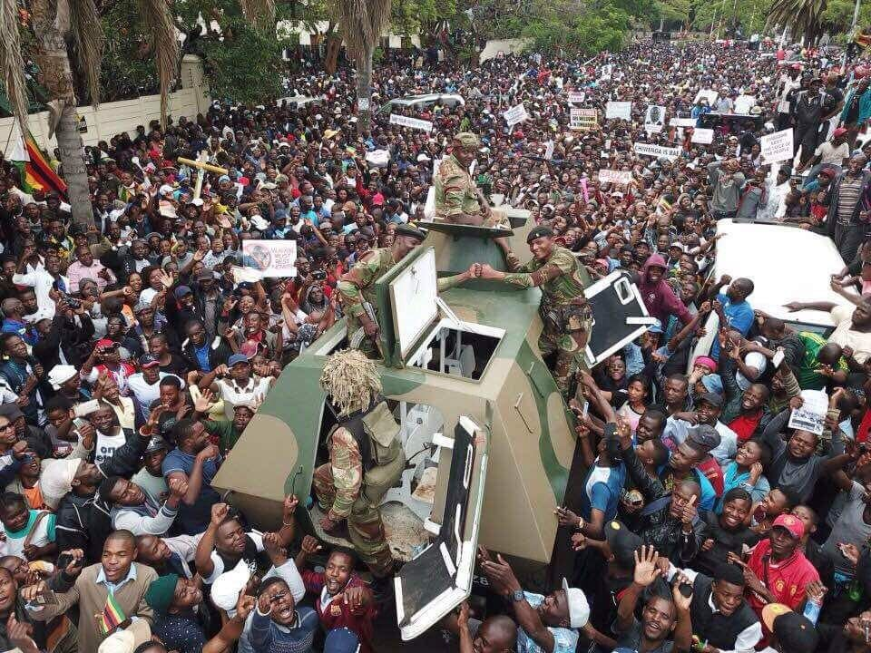

Fig 2.o People’s Revolt or Scripted Factional Battles?

The perceptive Maggie Dongo said ‘the fight between G40 and Lacoste has nothing to do with Zimbabwe and Zimbabweans’. The Generals were very clear that they are doing some ‘house cleaning’ and prior to that General Chiwenga and Air Marshal Shiri had given ominous warnings. If history’s archives were prized open one would discover that this was a Mgagao Number 2 and the ‘nationalists’ have been vanquished by those with military might.

If the gyrations of the General’s wife right in the tent and behind the President is anything to go by then we are headed for demanding times. From now onwards we risk seeing the Presidency being handed down and exchanged amongst those with military training and liberation war credentials only. Tendai Biti has already pointed out that it is very rare in African political adventures to see the tanks only once on the streets. Our warning is very simple: ED is the mask of the securocrats in Zimbabwe. Now that he is President and if elected he will be beholden to the securocrats and we have seen, historically, how they behave when they are challenged democratically at the ballot box. Government by operations like Operation 'short sleeves' and 'operation mavhotera papi' while they loot the state through 'command economy'. ZANU PF’s party-state machinery has been reproduced carte blanche and if the MDC Alliance believes in a social democracy project for Zimbabwe the most patriotic thing they can do is to refuse to be part of any elite pact with the securocratic party-state and get down to the business of organising and mobilizing its constituency.

Civil Society, Opposition and Zimbabwe’s Democratic Discourse

Professor David Moore has recently warned that ‘when the state is the man and the man is the state’ it is bound to cause problems. This analysis is based on a very structural and objective analysis of how Zimbabwe’s party-machinery is easily domineered and fashioned to serve the interests of a ruling elite than the citizenry. The basis of the social and labor movements and the social democracy project through the MDC was a clear and unequivocal rejection of a particular mode of rule which Professor Brian Raftopoulos called ‘nationalist authoritarianism’.
For a national psyche which has been chained in a gulag of Stalinist proportions even the minuscule whisper and apoplectic promise of freedom is bound to generate excitement. We are now lingering in the desert of a post-Mugabe epoch in which the surface has been seductively painted but the logic of the nationalist authoritarian state remains intact and very soon it will commence its unfettered surveillance of the citizen. The price of freedom and liberty is eternal vigilance and not cooption to the feeding trough. After all we are now swimming in disturbed and very murky waters and the crocodile has thousands of years in evolutionary advantage. Like that Italian philosopher in prison we are simply rubbing ‘intellect and will’.

*Tinashe L. Chimedza &Tamuka C. Chirimambowa are the Co-Editors of Gravitas a publication of the Institute of Public Affairs in Zimbabwe (IPAZIM). Contact gravitas@ipazim.com.

Latest publications.

Book.

Magidimisha, H.H., Khalema, N.E., Chipungu, L., Chirimambowa, T., Chimedza, T. (2017) (Eds.) Crisis, Identity and Migration in Post-Colonial Southern Africa, Springer: South Africa.

Book Chapter

Makwembere, Sandra., Chirimambowa Tamuka and Chimedza, Tinashe, (2017) Hamster Wheel in a Democracy: The Redudancy of Elections in Southern African Countries? in Sebola, P (Ed.) Politics, Elections, Local Government and Administration. Batalea Publishers: South Africa.

