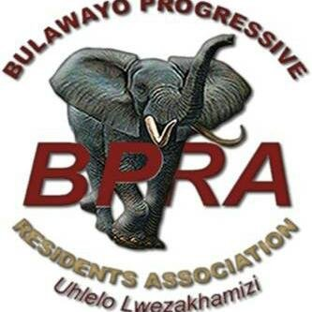

BPRA WHATSAPP Q&A WITH THE MAYOR- FRIDAY 8TH MAY 2020
*The first 15 questions directed at the Mayor were submitted by Bulawayo residents via WhatsApp and Twitter prior to the meeting. The Q&A session was opened by Mr. Kelebone Khabo- Bulawayo Progressive Residents Association (BPRA) Communications Manager and moderated by BPRA Secretary for Administration Mr. Thembelani Dube.
*Date: 8 May 2020
*Venue: BPRA WhatsApp Group
Time: 19:00hrs- 20:10hrs.

KHABO: Good evening zakhamizi. The time we have all been waiting for is now here. Our Mayor uCllr S. Mguni is now with us in the group. Siyakwamukela Mayor. Our moderator for the day is Thembelani Dube the BPRA Exec Secretary for Admin. We shall now close the floor for comments until the Mayor is done answering the questions we have compiled njenge zakhamizi. Once again welcome Mayor. Mr Thembelani Dube the floor is now yours.
Dube: Thank You.
Mayor: Thank you for having me. Good evening Bulawayo.
DUBE: GOOD EVENING YOUR WORSHIP CLLR S. M. MGUNI. WELCOME TO BPRA WHATSAPP PLATFORM QUESTION & ANSWER SESSION ON 08 MAY 2020.
Question 1: From the several grants given to Zimbabwe for the fight against COVID-19 we have read about in newspapers, has BCC received anything?
MAYOR: We have received $10m for renovations at Thorngrove Hospital and a $3,6m for recurrent expenditure. We continue to receive materials for fighting COVID19 from Government without reference to what funding sources were used, except for the donations received from Jack Ma, and other organisations that directly approach Council.
DUBE: Question 2: Taking note of the fact that new water sources such as Bowsers and community boreholes have become high risk places for contracting or spreading the COVID 19 virus, what measures has the city council put in place to make sure that social distancing is observed and other elements to protect people from spreading or contracting virus?
Mayor: Community boreholes are managed by communities and Residents Associations should assist in stepping up using their structures to organise people. The City of Bulawayo water delivery crews have masks and hand sanitisers which they use during water delivery. They do not wear gloves due to the fact that we emphasise on handwashing or sanitising of hands. COVID-19 is suspected to stick to gloves for longer periods and easy to pass when on latex gloves. The crews are encouraged to frequently sanitise their hands. They have also incorporated social distancing in their operating procedure thus they encourage residents to maintain social distance whenever they do water delivery although this is not easy to enforce due to big crowds at water points. The City has also been conducting awareness campaigns at points where bowsers deliver water. Residents are therefore requested to cooperate with the crews whenever collecting water from the distribution points.
DUBE: Question 3: In as far as the issues of vendors are concerned, what mechanism has been put in place to ensure that those vendors who have been displaced benefit first? How do we ensure that we first deal with those affected before giving new vendors the bays?
Mayor: The displaced vendors are documented and as such are a priority.
DUBE: Question 4: It is alleged that BCC will be disconnecting water for non payment during the COVID-19 lockdown. How far true is that?
Mayor: In as much as disconnection of water is a debt recovery measure; the city is alive to the plight of residents during this lockdown period. We are aware that most of our ratepayers are in the informal sector that has been locked down by covid 19. We however encourage residence to approach our revenue halls with whatever they have and make payment plans so that we don’t also lockdown service delivery.
DUBE: Question 5: What is the progress on the eGodini Mall now that the Vendor markets have been closed down due to COVID 19?
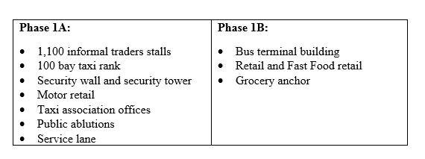
Mayor: The Egodini Project is still ongoing. The first phase of the Project which has been divided into Phase 1A and Phase 1B consists of the following;
The timeline for Phase 1A will be approximately 5 months, Phase 1B will be approximately 7 months done concurrently with Phase 1A. On the successful completion of Phase 1, the Developer and the City of Bulawayo will jointly work on a program for the implementation of Phase 2 and Phase 3.
DUBE: Question 6: In ward 21,I heard that the vendors will be allocated at Tshabalala Market, are they referring to Emkambo,because it was allocated before, this COVID pandemic, the bays are all occupied, where are they going to be put, there is not enough space, is this not going to cause congestion, and an outbreak of this Covid.19 disease?
Mayor: Tshabalala market has unallocated bays. The area also has available space to accommodate as many vendors.
DUBE: Question 7: What are the short and long term plans to address the water crisis?
Mayor: The potential to cover the gap is through the implementation of the following sustainable projects, which have been submitted to Government. Further development and extension of the Nyamandlovu Aquifer towards Sawmills in Tsholotsho. It is envisaged to supply an estimated combined (Rochester & Epping Forest) ground water potential yield of 20Mℓ/day. Presently the Nyamandlovu Aquifer scheme currently supplies on average 3-4 Mℓ/day out of potential of 20 Mℓ/day. Mtshabezi Dam has the potential to supply maximum raw water of up to 25 Mℓ/day. Currently the dam can supply 15 – 17 Mℓ/day. A potential of 8 – 10 Mℓ/day is available, if the bulk-pipelines from Mtshabezi to Ncema Water treatment works are upgraded and improve conveyance capacity by (32 – 40) %.

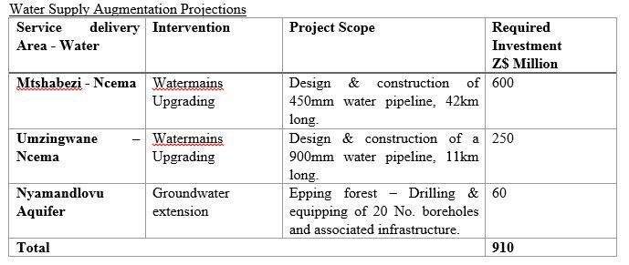

It should be noted that these projects are medium to long term and are not likely to be completed before the decommissioning of the Lower Ncema Dam in May. In the long term, the completion of the Gwayi – Shangani Dam should ease the City’s water challenges and there after the completion of the Matabeleland Zambezi Water project.
DUBE: Question 8: How far has the Nyamandlovu Aquifer rehabilitation gone?
Mayor: The Zimbabwe National Water Authority has started rehabilitating Nyamandlovu Aquifer Boreholes in an emergency programme to augment the City’s Water supply. The team started this week, following receipt of a $10.6 million grant from Government to rehabilitate 15 Boreholes.
DUBE: Question 9: We received reports that some water meter readers in some suburbs claim to have remote sensing gadgets to detect water meter readings whilst standing at the gate without checking the meters. Does BCC have such gadgets? Case in point: Mpophoma.
Mayor: The City of Bulawayo has been using meter reading gadgets from as far back as 2014 in a bid to improve efficiency and effectiveness in the meter readings. The advantage is that the gadgets automatically pick up the location of the meter and link to the Council Billing System ensuring that there is no duplication or incorrect meter readings. Some of the advantages of this is that it is quicker to use, ensures accuracy of readings is enhanced as the gadget will always vibrate if a reading with a higher deviation is recorded, thus prompting Meter Reader to re check meter and they record the actual time at which he reads the meter is recorded and this will help optimize on time management.
DUBE: Question 10: We have perennial treated water leakages in the city which has been not attended for years. Who is footing the bill?
Mayor: The water lost is considered Non-Revenue Water. To attend to these challenges, the City is currently implementing the Bulawayo Water and Sewerage Services Improvement Project (BWSSIP) which is currently funding the rehabilitation of 45km out of a gap of 113 km pipeline that needs to be attended to. The system is old and in need of rehabilitation hence the numerous leaks on the System. The City needs more funding to attend to these.
DUBE: Question 11: The water bowsers are not being availed according to the schedule that was publicised. Why is that?
Mayor: There are challenges with increased demand for Water bowsers and the worsening Water situation. Efforts are made to ensure that we stick to the schedule at all times.
DUBE: Question 12: Are there any plans to avail the water bowsers to more areas?
Mayor: Efforts are being made to avail more water bowsers. But of course we have funding constraints. Thats why we are now thinking of setting up water kiosks on high lying areas.
DUBE: Question 13: Is it possible for BCC in the coming weeks to arrange for a tour for BCC Engineers, BPRA and Councillors to the six supply dams, Nyamandlovu Aquifer, Gwayi-Shangani Dam for the residents to have appreciation of the dam levels as well as BCC's water supply efforts?
Mayor: Taking into consideration the challenges of the COVID-19 pandemic, this trip may not be possible as there are issues of social distancing to consider as well as the number of people that can congregate at a particular time. It is also important to note that the Nyamandlovu Aquifer and Gwayi Shangani are under the custodian of the Government of Zimbabwe through ZINWA. The City will need to engage them once the threat of COVID-19 have passed.
DUBE: Question 14: What is the criteria for giving the 3000+/- stands that we heard will be released this year. Why do we have to be on a waiting list if they are going to focus on those with ready money?
Mayor: 3 000 residential stands is an annual target for Council as per corporate strategic plan. Allocation of stands is based on the waiting list. The current strategy of pre-sale is self-financing .The programme has always been advertised where interested residents would apply. Those will then be allocated on a first come first served basis (taking into consideration other factors such as age of waiting form, gender, disability etc). As such, this year's target maybe achieved through other approved strategies such as Public Private Partnerships (PPPs), private subdivisions and even pre-sale schemes.
DUBE: Question 15: What are the plans to fix streetlights and tower lights around Bulawayo?
Mayor: Fixing of street lights is currently a low priority in the City due to funding constraints from limited revenue inflows, government policies which had a financial implication in the City such as the Statutory Instrument 142of 2019 which saw over USD200million budget reducing in currency value, while pricing from suppliers remaining in USD. However; once collections and funding permits; we will look into the issue of street lighting because its important in as far as public safety is concerned. For now water augumentation is top of the priority.

DUBE: Members can now ask questions on issues *NOT* tackled today and His Worship will answer some today and others them in our next session due to limited time.
Resident 1: There are reports that BCC is considering drawing water from Khami dam. Is this true? Does council have the capacity to purify the water?
Mayor: The issue of Khami water is not yet a resolution of council. Suggestions have been made by individuals but its something that may need wider consultations and resources.
Resident 2: The council continue to give tenders to contractors who while they haven't finish previous projects as results rate payers will end up taking the responsibility and the council doesn't offset ie mahatshula has got 2 grey areas with no roads yet council is taking rates, no refuse collection
Mayor: What we must all understand is that there has been lots of constraints in finalising projects in view of the economic realities on the ground. We have worked with contractors to review time lines and allow them to finish the project. In some instances residents have been engaged to adjust any amounts that could have been paid so that we see through these projects.
Resident 3: Does BCC have a skills database for youths and professionals in Bulawayo so as to develop local capacities and create employment opportunities for the Locals?
Mayor: Employment creation is everyone’s responsibility. Not the city alone. Public sector and private sector alike has a responsibility to create employment for our people. We must now have a yourh that create employment and we are grateful to our institutions of higher learning; for instance; NUST which has mooted the idea of innovation hubs in partnership with the city and various stakeholders.
Resident 4: Informal Traders Relief Fund : is Council in picture of when these funds will be distributed as they have the data base of all registered vendors?
Mayor: That’s the responsibility of the Ministry of SMEs and they are using the vendors data base and informal sector as provided by council.
Resident 5: Why is council failing to run beerhalls and leasing them out to individuals who do not even plough back to the communities that have become their cash cows?
Mayor: Times have changed. Bottles stores and sports clubs have taken over the show. If we are to run beerhalls; we need to ask many questions. Firstly; whats our core mandate? Is it to do business or to facilitate doing of business? Secondly; how many of our people are drinking opaque beer? Whats the cost of operation o f the beerhalls vis-a-vis the profits from those beerhalls? Do we still have a share of the market in 2020 that we had in 1965?
Resident 6: We have issues of borehole around the city which residents are getting water from especial in high density surbubs like Nkulumane/ Nketa and Mganwini at the time when we have water crisis. Why cant the council monitor those borehole until the water crisis is over. Yes we have bee raising these issues with the Bcc council at other meetings to be told the Residents should look after them. But the issue is there are some project which where granted by the council where the borehole are in those areas and the owners are refusing to allow residents to have access to water e.g. the garden of near Nketa community hall.
Mayor: Boreholes are sunk depending on survey results. Where there is no underground water; there can’t be a borehole. These boreholes are community boreholes donated by well wishers sometime ago. Council is coming in to assist with repairs in this time of crisis. We would expect the community to come up with measures for security of their boreholes. Council’s wage bill is already too high to deploy security to manage these community boreholes.

DUBE: For today I'm sure we have to leave it here. Mhlonitshwa your parting words to the residents of Bulawayo?
Mayor: Thank you Bulawayo for being responsible citizens in this time of crisis. Together we will win against the pandemic. Lets continue exercising safe hygiene and where possible stay at home. Lets pay our bills; whatever we can afford for now. Help the city to help you. We can’t lock off service delivery even during this period of lockdown. Thank you for the support that you are giving me as tour mayor during this turbulent tenure of my office as well as the support that you are giving to my fellow councillors and staff. Lets continue to engage. We love you. God bless you.
DUBE: Thank you our Bulawayo Mayor and everybody on this BPRA platform. Uhlelo LweZakhamizi. Goodnight and be safe from covid-19.

